**VISVESVARAYA TECHNOLOGICAL UNIVERSITY**

**“JnanaSangama”, Belgaum -590014, Karnataka.**



**LAB REPORT**

**on**

OBJECT ORIENTED MODELING AND DESIGN

***Submitted by***

**DISHA N (1BM19CS051)**

***in partial fulfillment for the award of the degree of***

**BACHELOR OF ENGINEERING**

***in***

**COMPUTER SCIENCE AND ENGINEERING**



**B.M.S. COLLEGE OF ENGINEERING**

**(Autonomous Institution under VTU)**

**BENGALURU-560019**

**April-2022 to July-2022**

**B. M. S. College of Engineering,**

**Bull Temple Road, Bangalore 560019**

(Affiliated To Visvesvaraya Technological University, Belgaum)

**Department of Computer Science and Engineering**



**C ERTIFICATE**

This is to certify that the Lab work entitled “**OBJECT ORIENTED MODELING AND**

**DESIGN** ” carried out by **DISHA N (1BM18CS051),** who is bonafide student of **B. M. S. College of Engineering.** It is in partial fulfillment for the award of **Bachelor of Engineering in Computer Science and Engineering** of the Visvesvaraya Technological University, Belgaum during the academic year 2021-2022. The Lab report has been approved as it satisfies the academic requirements in respect of an **OBJECT ORIENTED MODELING AND DESIGN - (20CS6PCOMD)** work prescribed for the said degree.

Sheetal V A **Dr. Jyothi S Nayak**

Assistant Professor Professor and Head

Department of CSE Department of CSE

BMSCE, Bengaluru BMSCE, Bengaluru

`

Index Sheet

|  |  |  |
| --- | --- | --- |
| **Sl.**  **No.** | **Experiment Title** | **Page No.** |
| **1.** | **College information system** | **4-9** |
| **2.** | **Hostel management system** | **10-15** |
| **3.** | **Stock management system** | **16-21** |
| **4.** | **Coffee vending machine** | **22-27** |
| **5.** | **Online shopping system** | **28-33** |
| **6.** | **Railway reservation system** | **34-39** |
| **7.** | **Graphics editor system** | **40-45** |
|  |  |  |
|  |  |  |
|  |  |  |
|  |  |  |
|  |  |  |
|  |  |  |
|  |  |  |
|  |  |  |

Course Outcome

**Ability to conduct practical experiments to solve a given problem using Unified Modeling language.**

**CO4**

Exercise 1: College Information System

1. **Write SRS**

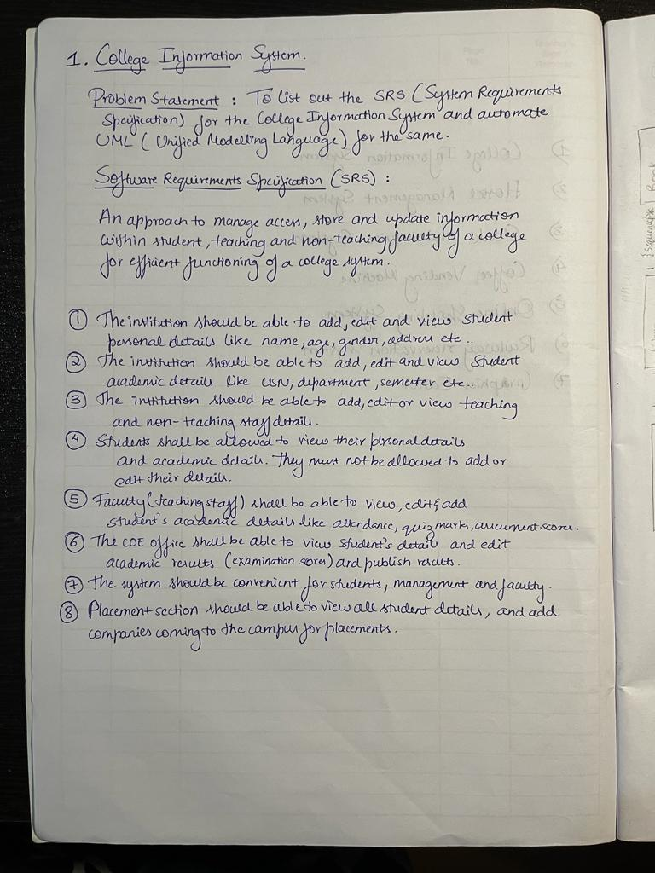

1. **Draw the advanced class diagram**

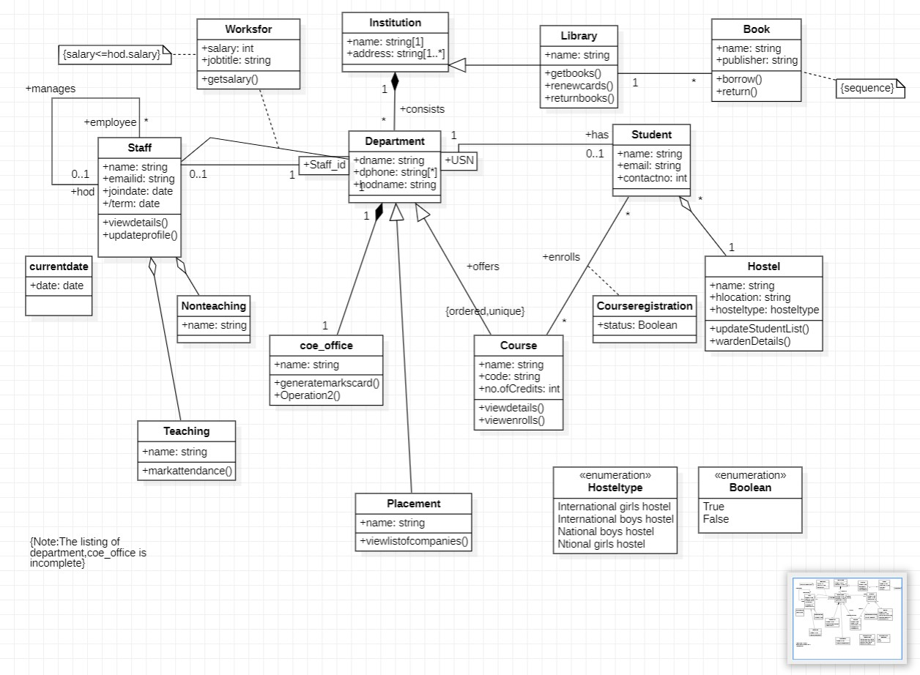

1. **Draw the advanced state diagram**

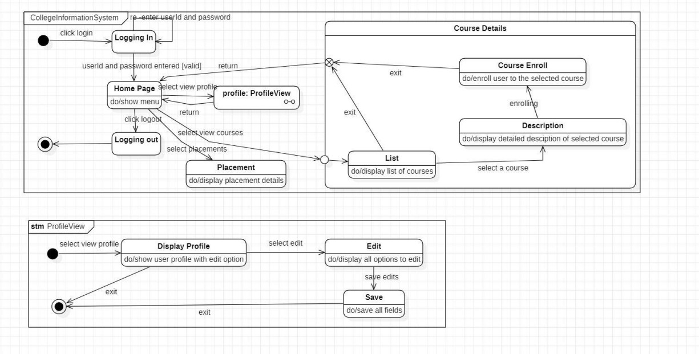

1. **Draw the advanced use case diagram**

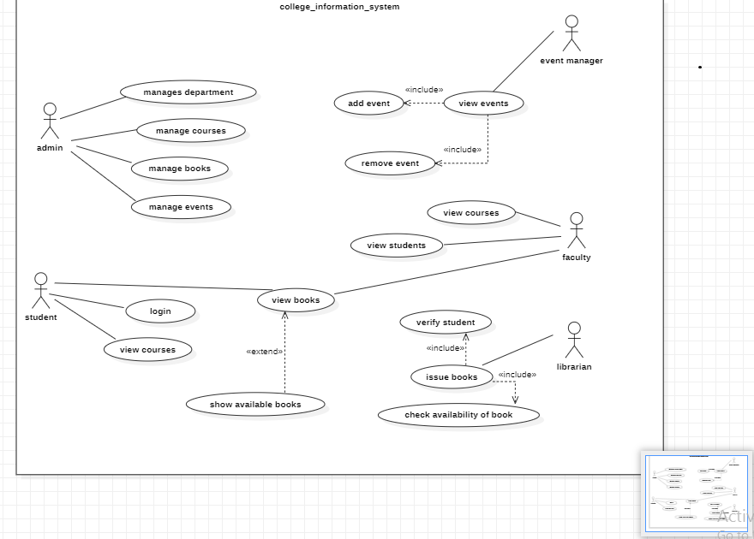

1. **Draw the advanced sequence diagram**

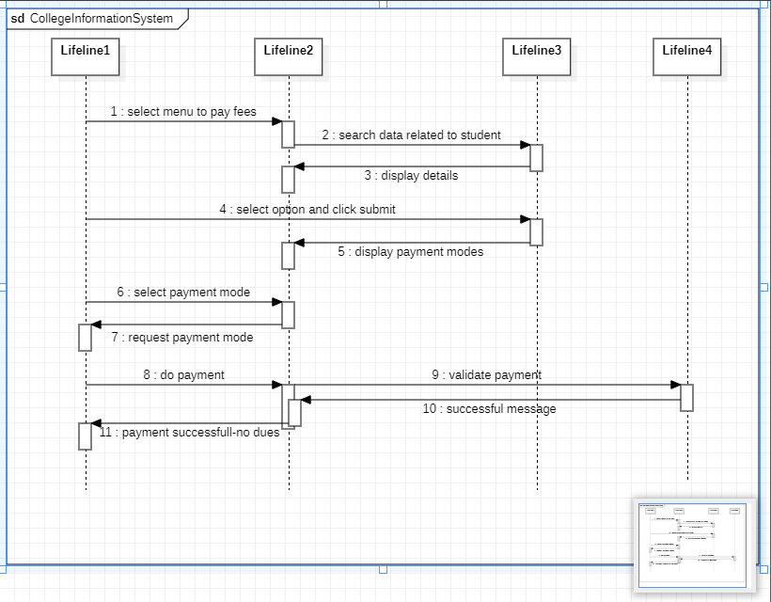

1. **Draw the advanced activity diagram**

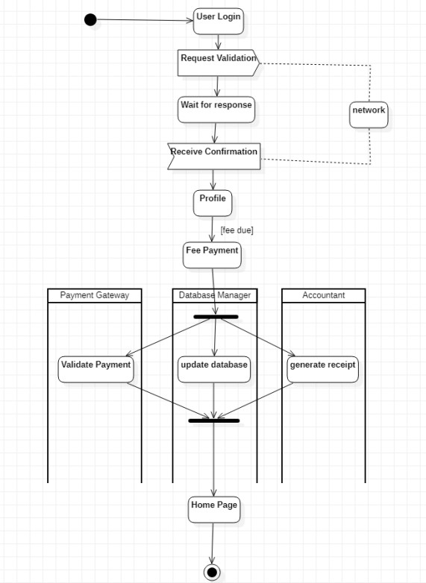

Exercise 2: Hostel Management System

1. **Write SRS**

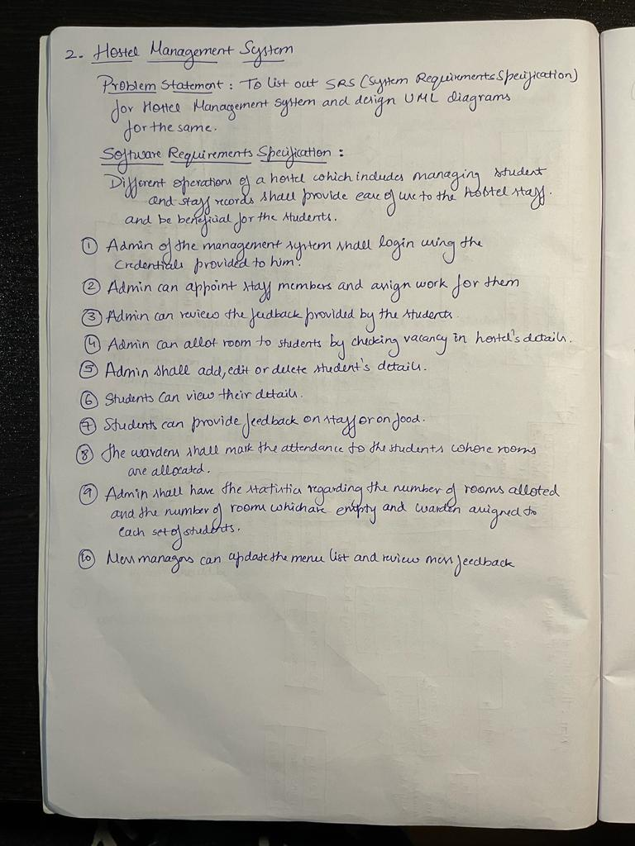

1. **Draw the advanced class diagram**

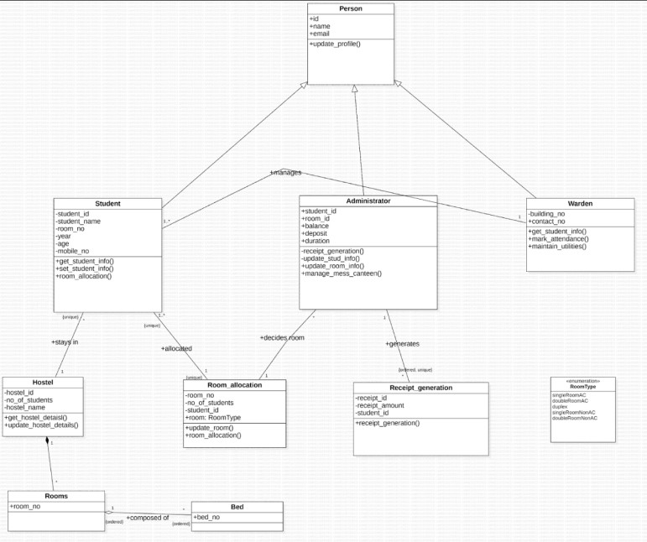

1. 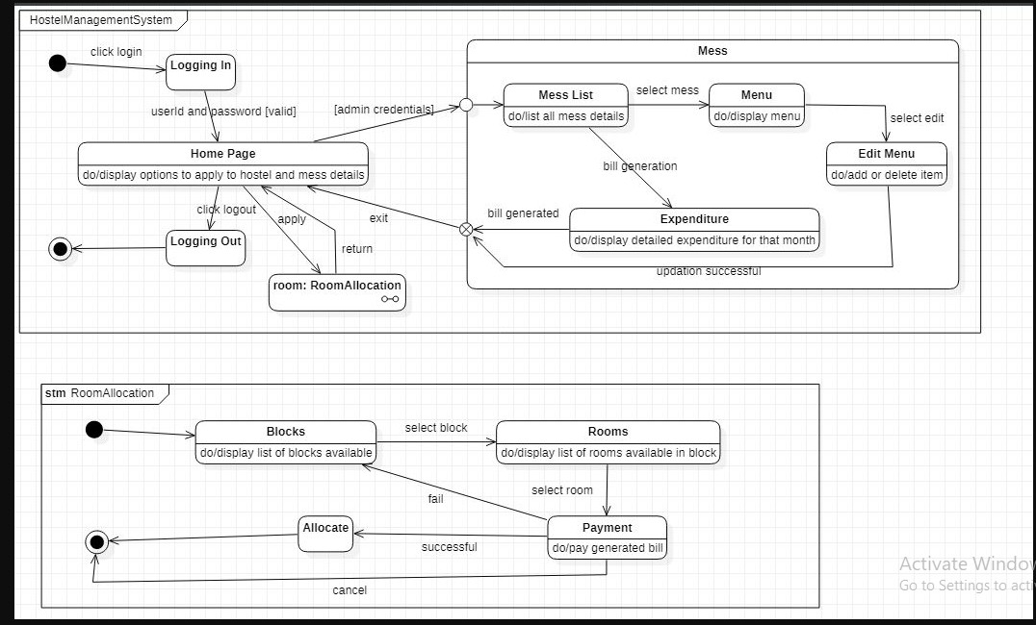**Draw the advanced state diagram**
2. **Draw the advanced use case diagram**

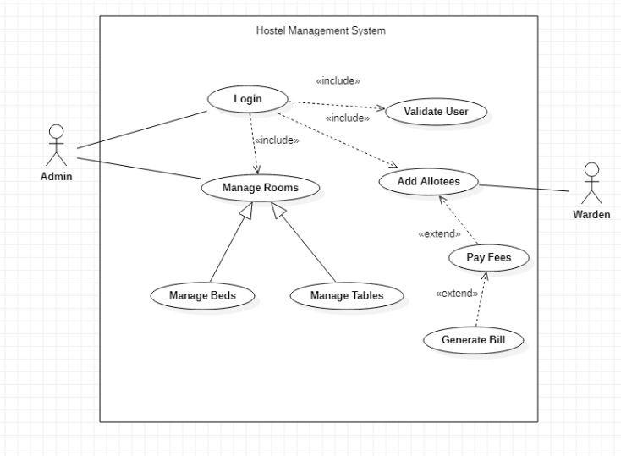

1. **Draw the advanced sequence diagram**

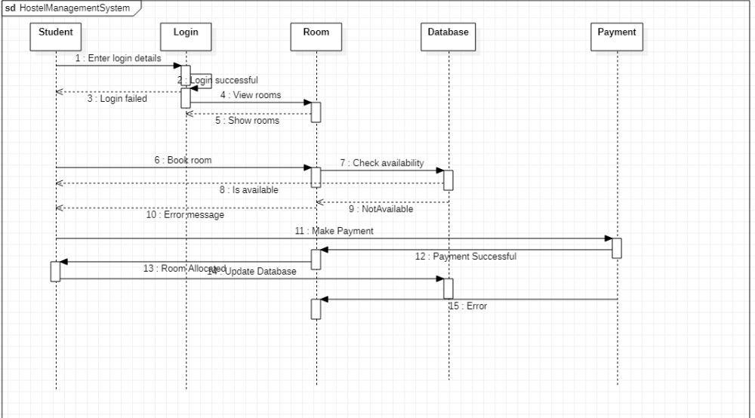

1. 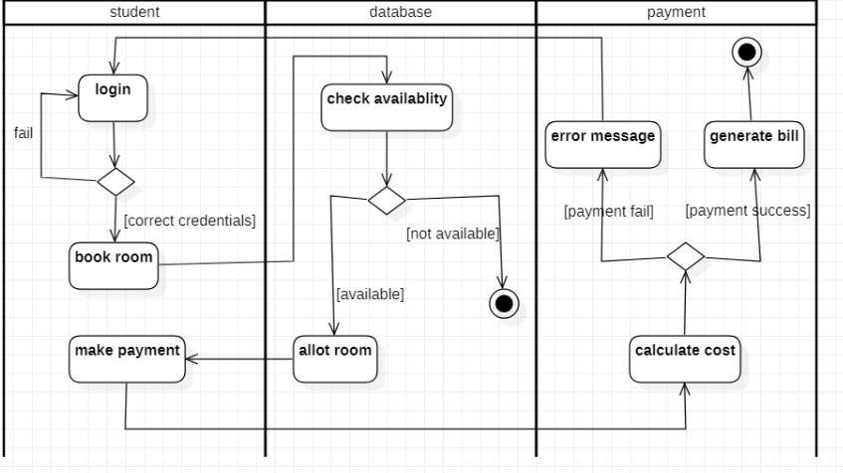**Draw the advanced activity diagram**

Exercise 3: Stock Management System

1. **Write SRS**

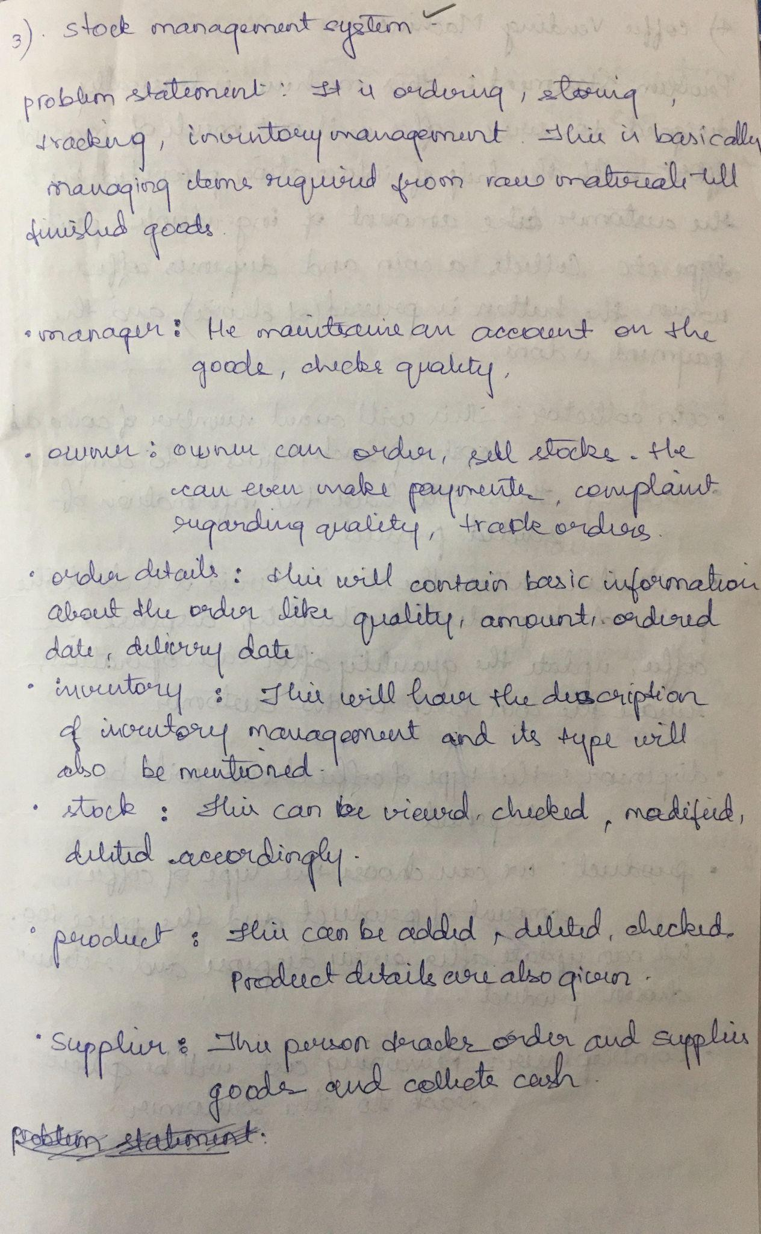

1. **Draw the advanced class diagram**

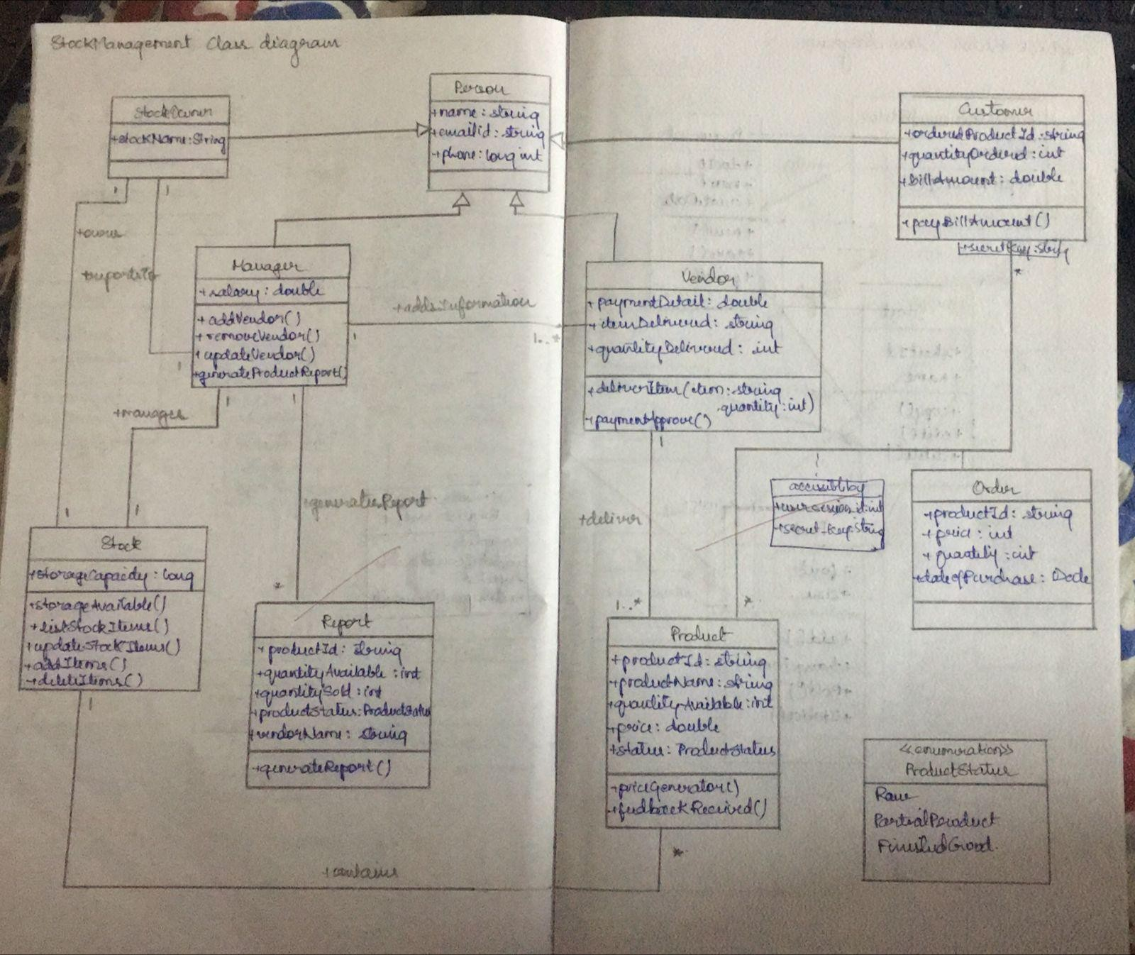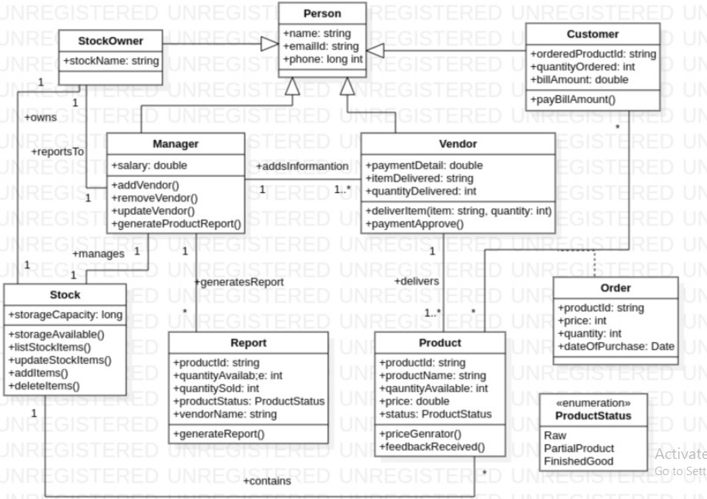

1. **Draw the advanced state diagram**

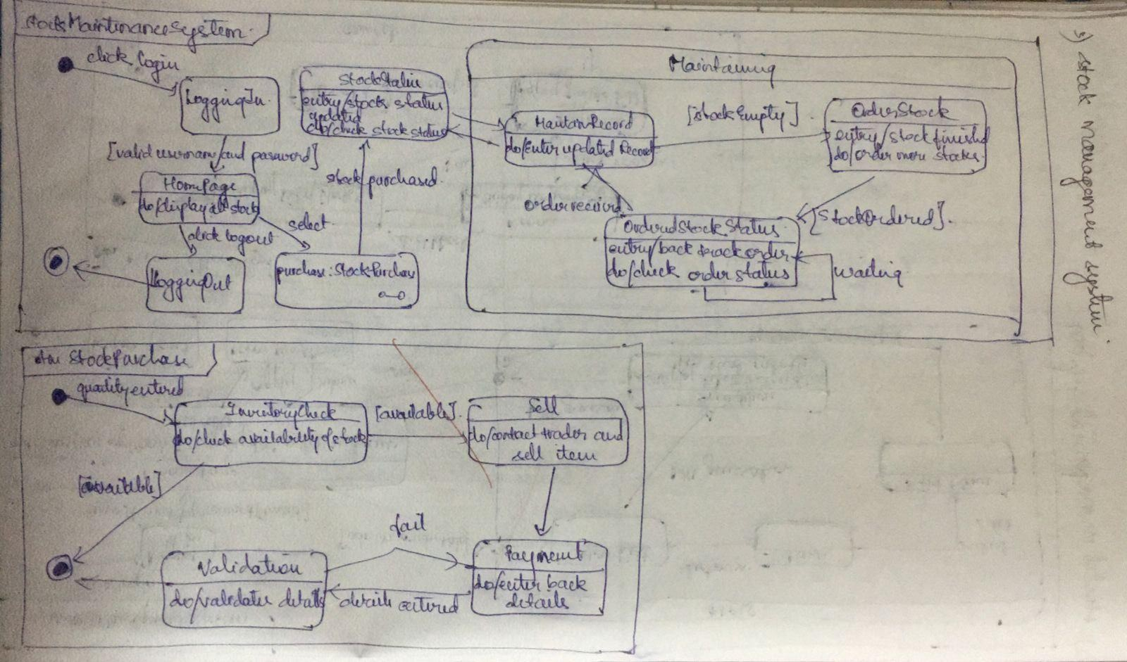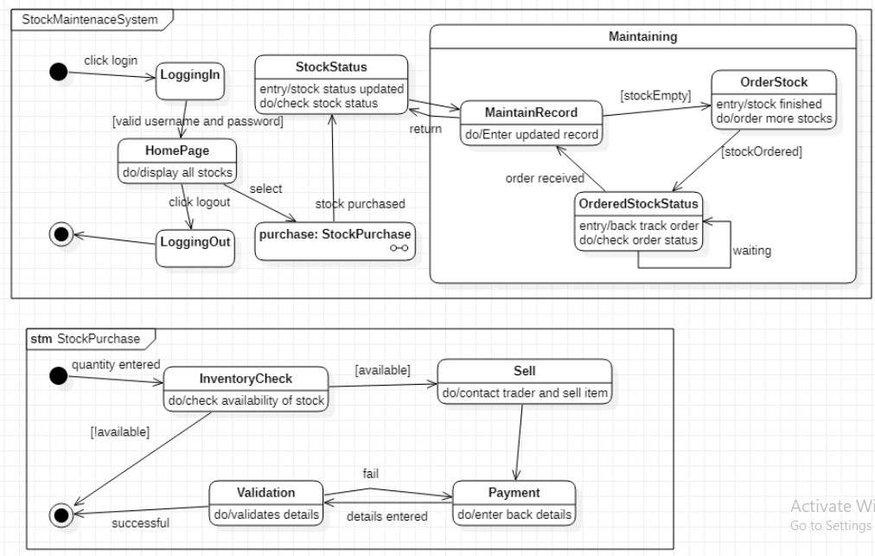

1. **Draw the advanced use case diagram**

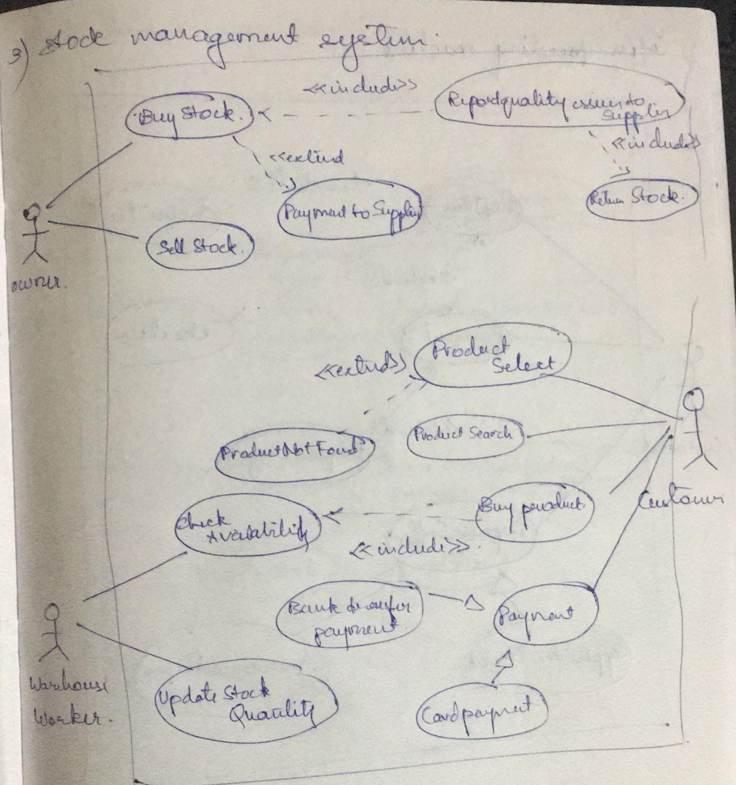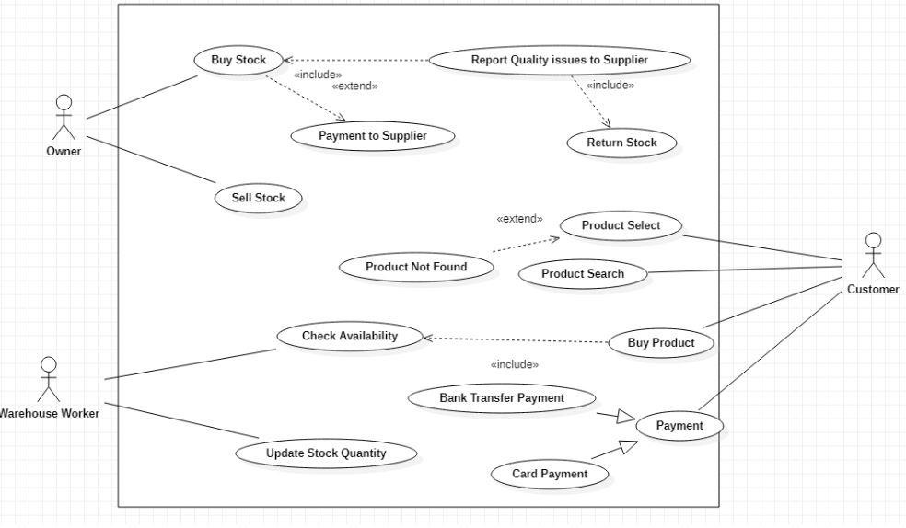

1. **Draw the advanced sequence diagram**

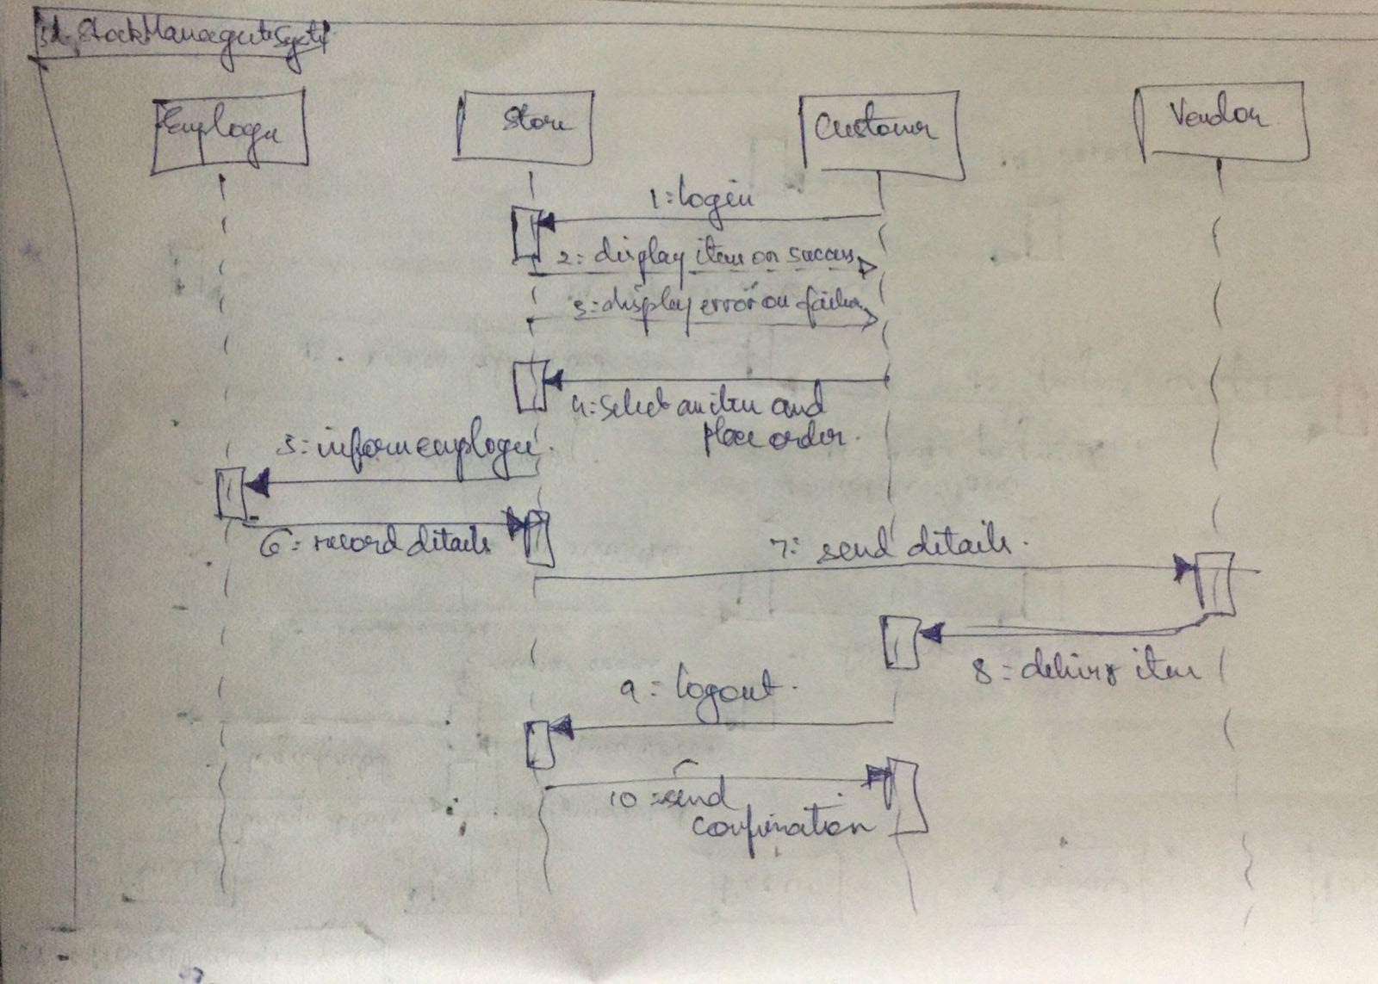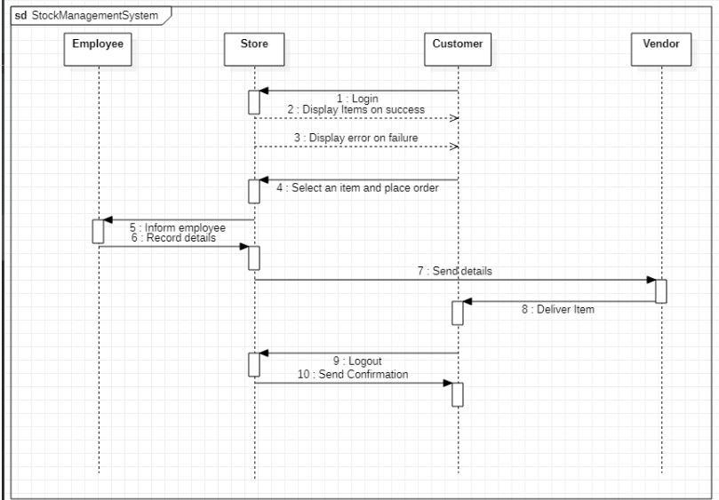

1. **Draw the advanced activity diagram**

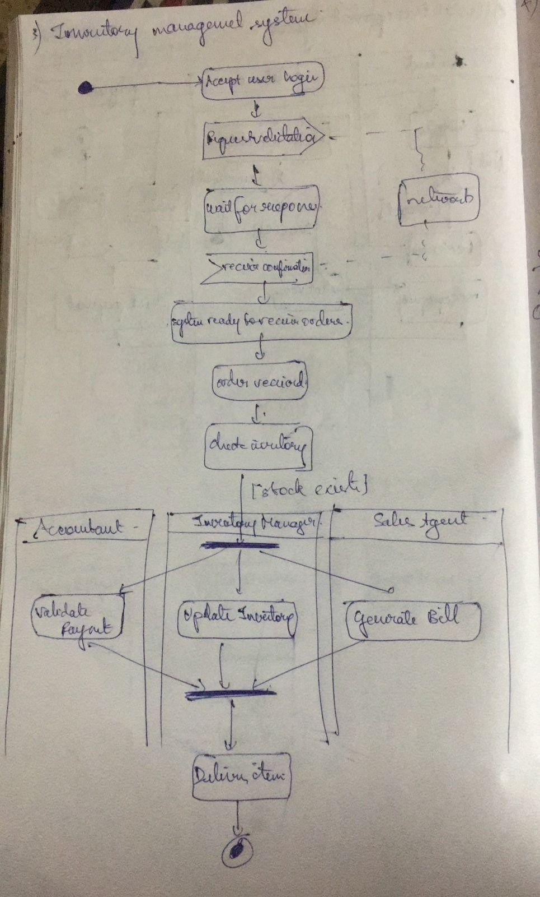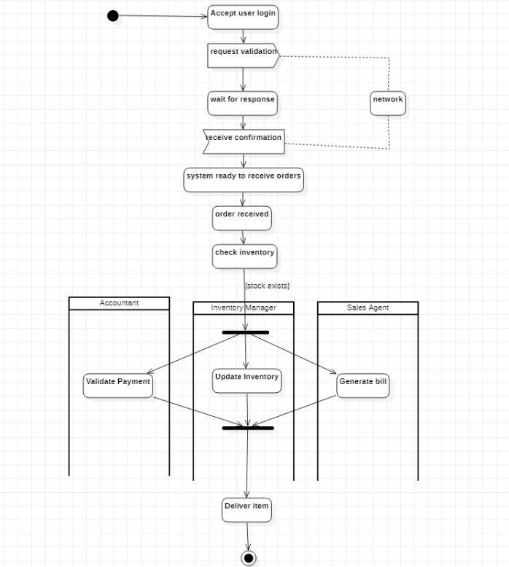

Exercise 4: Coffee Vending Machine

1. **Write SRS**

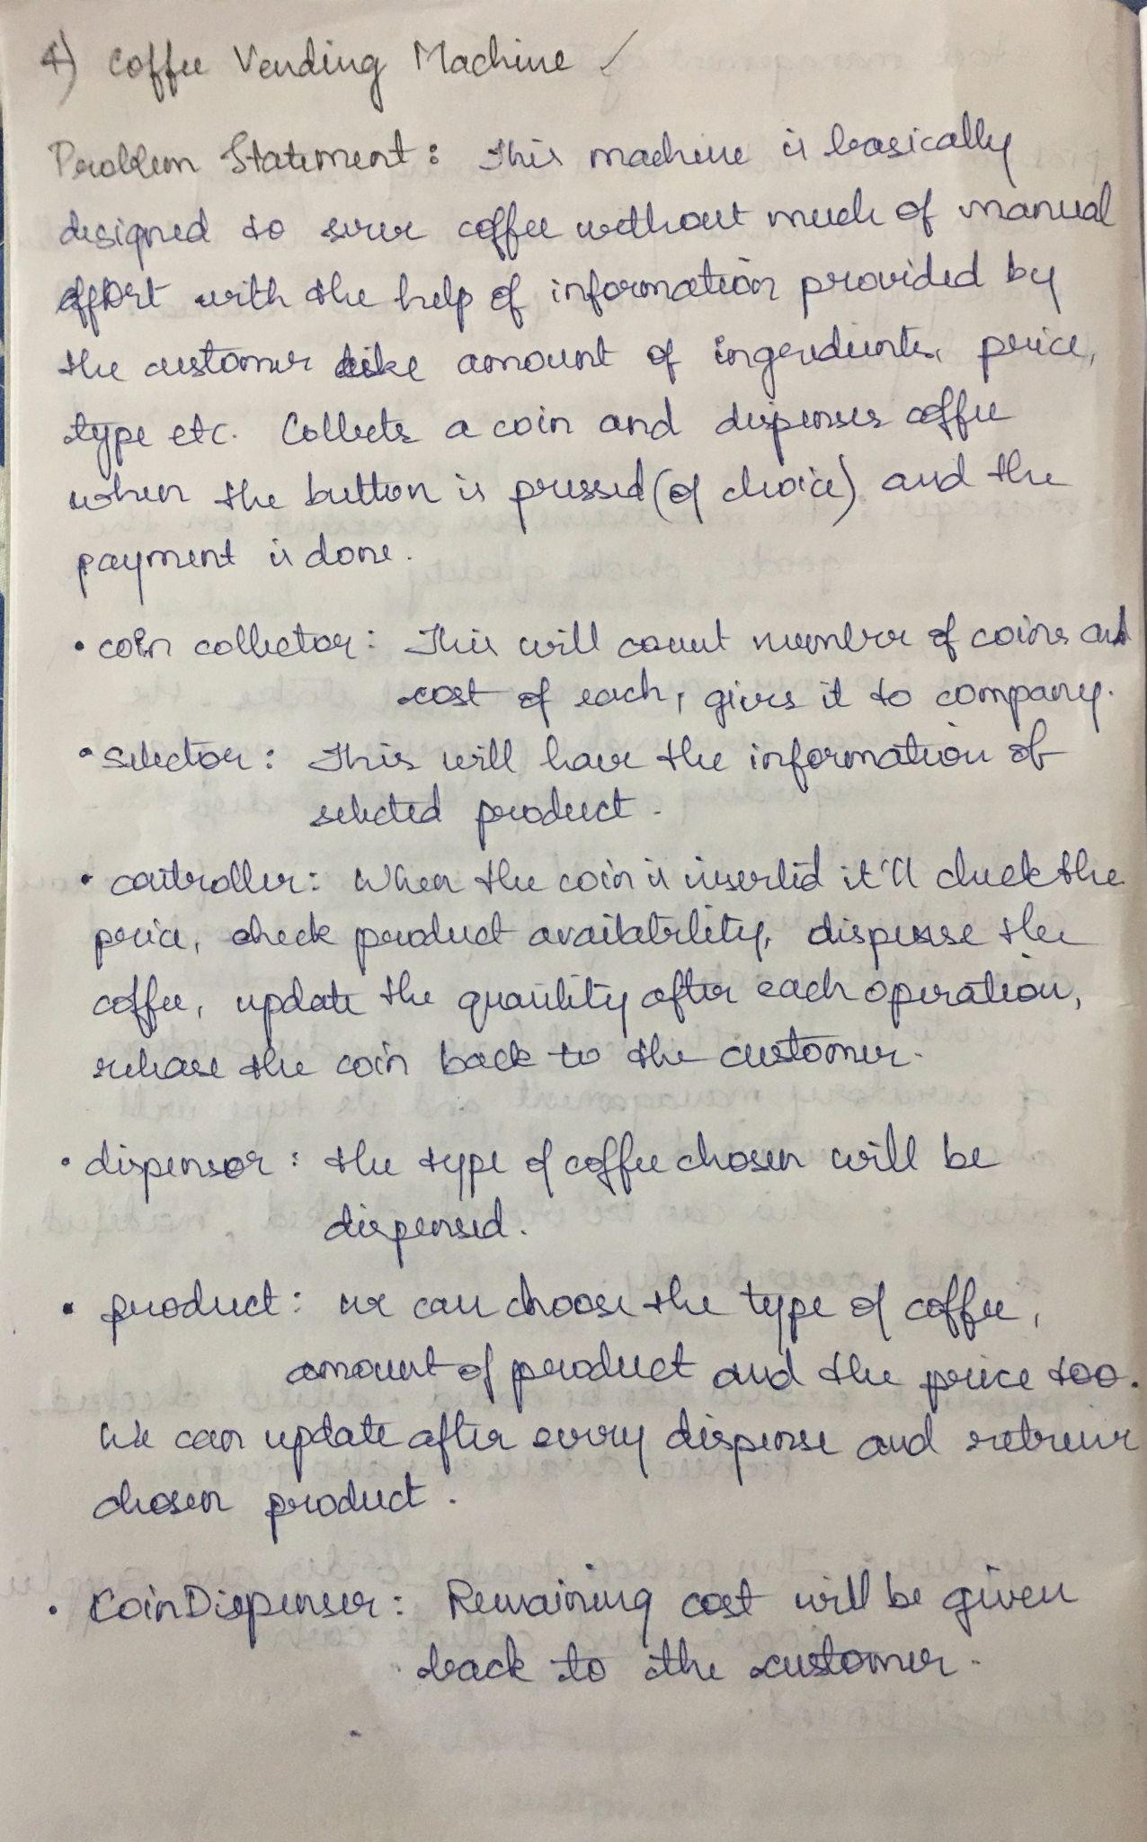

1. **Draw the advanced class diagram**

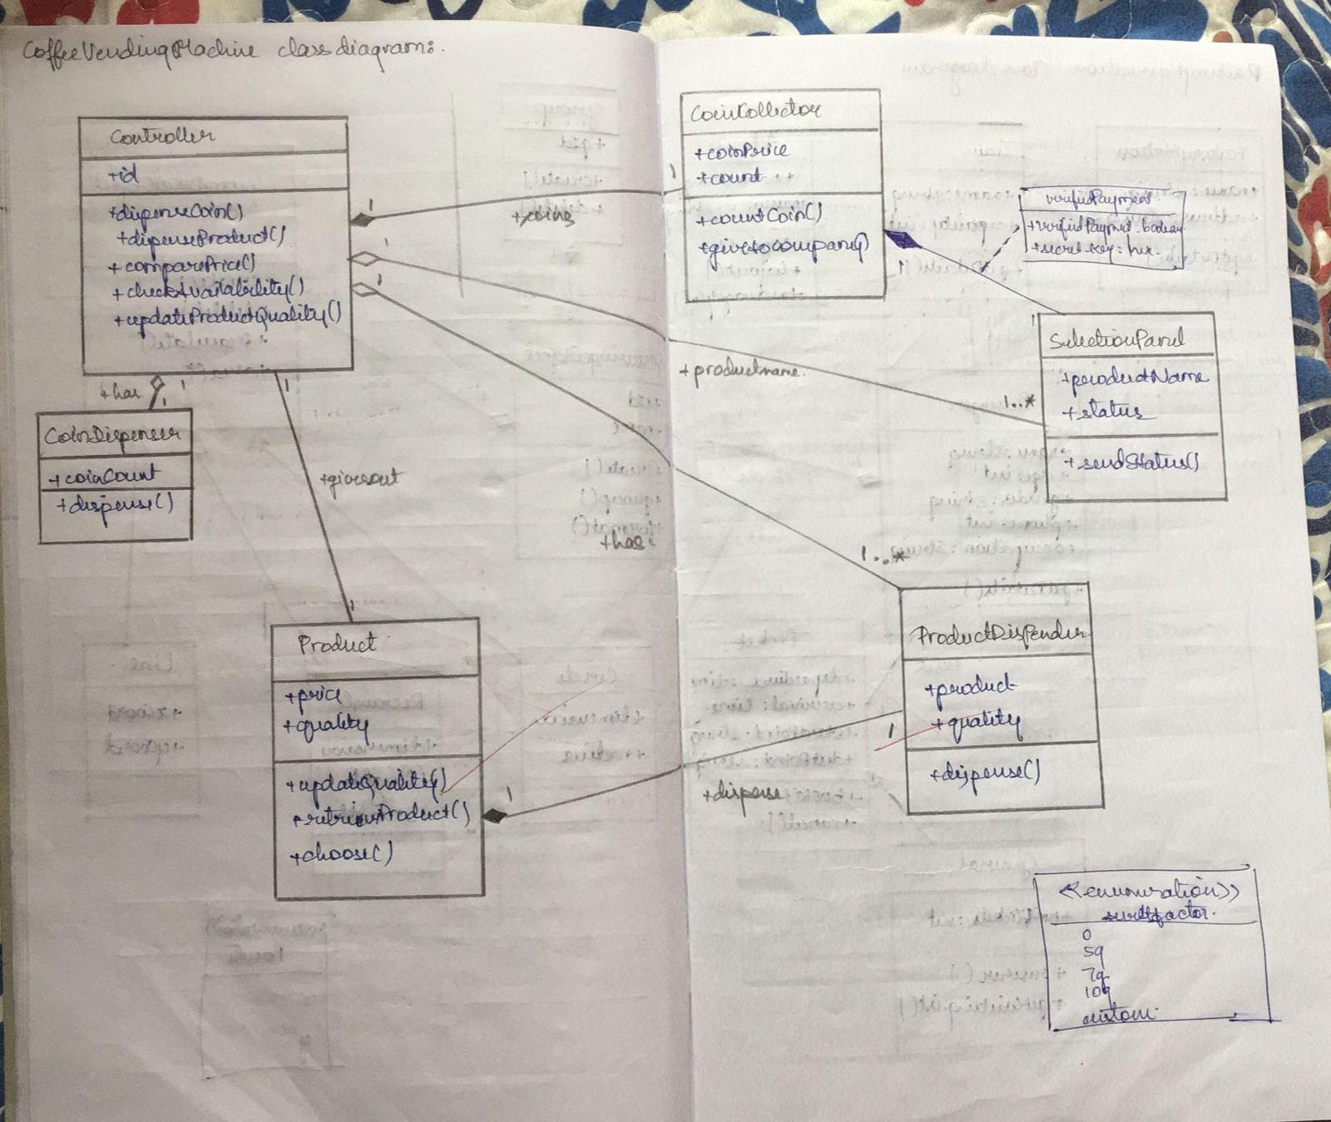

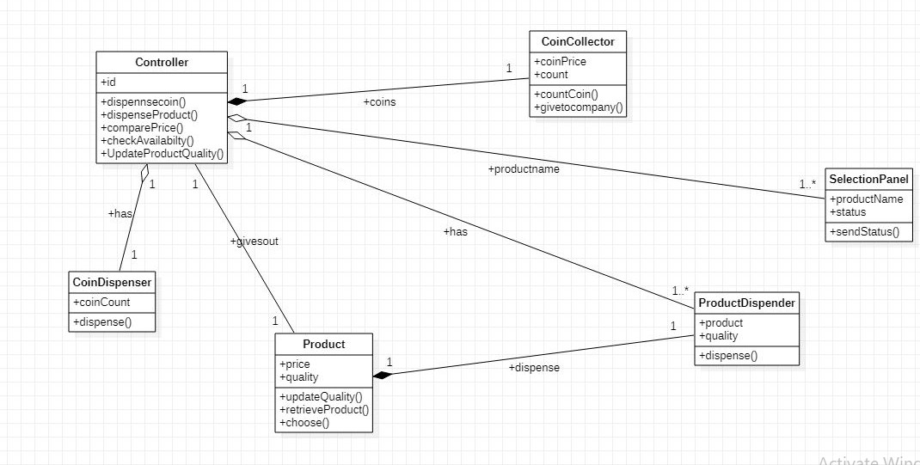

1. **Draw the advanced state diagram**

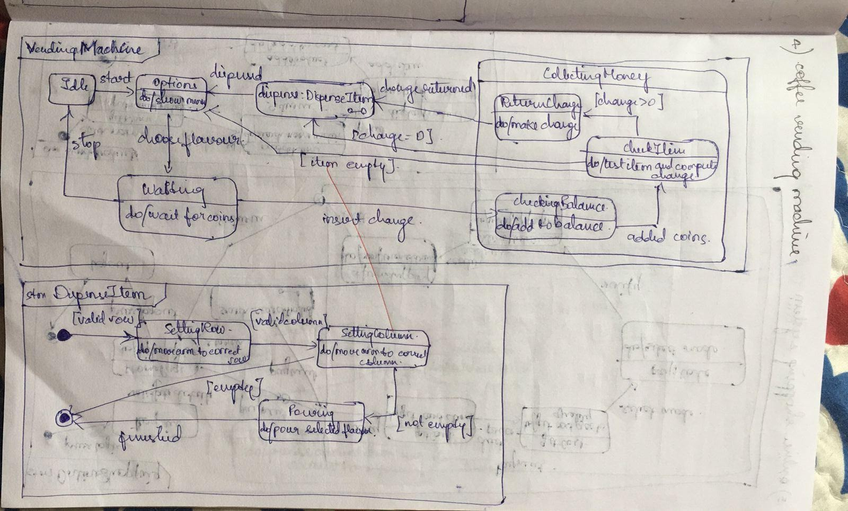

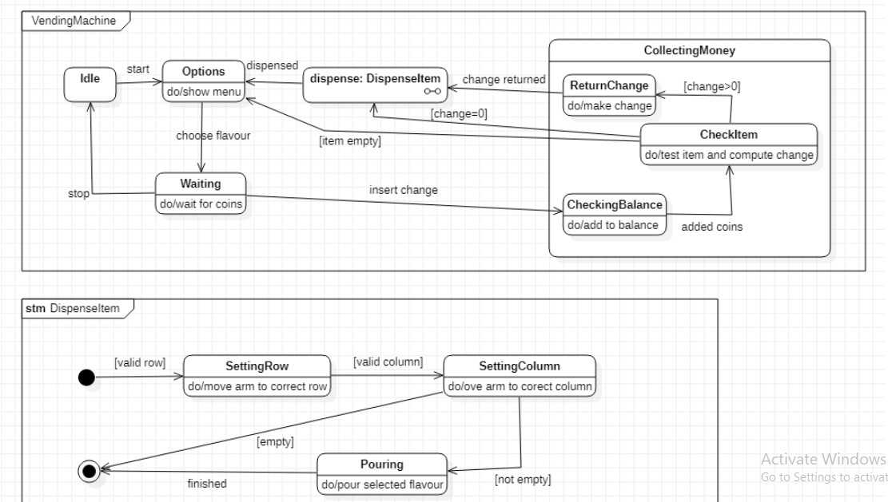

1. **Draw the advanced use case diagram**

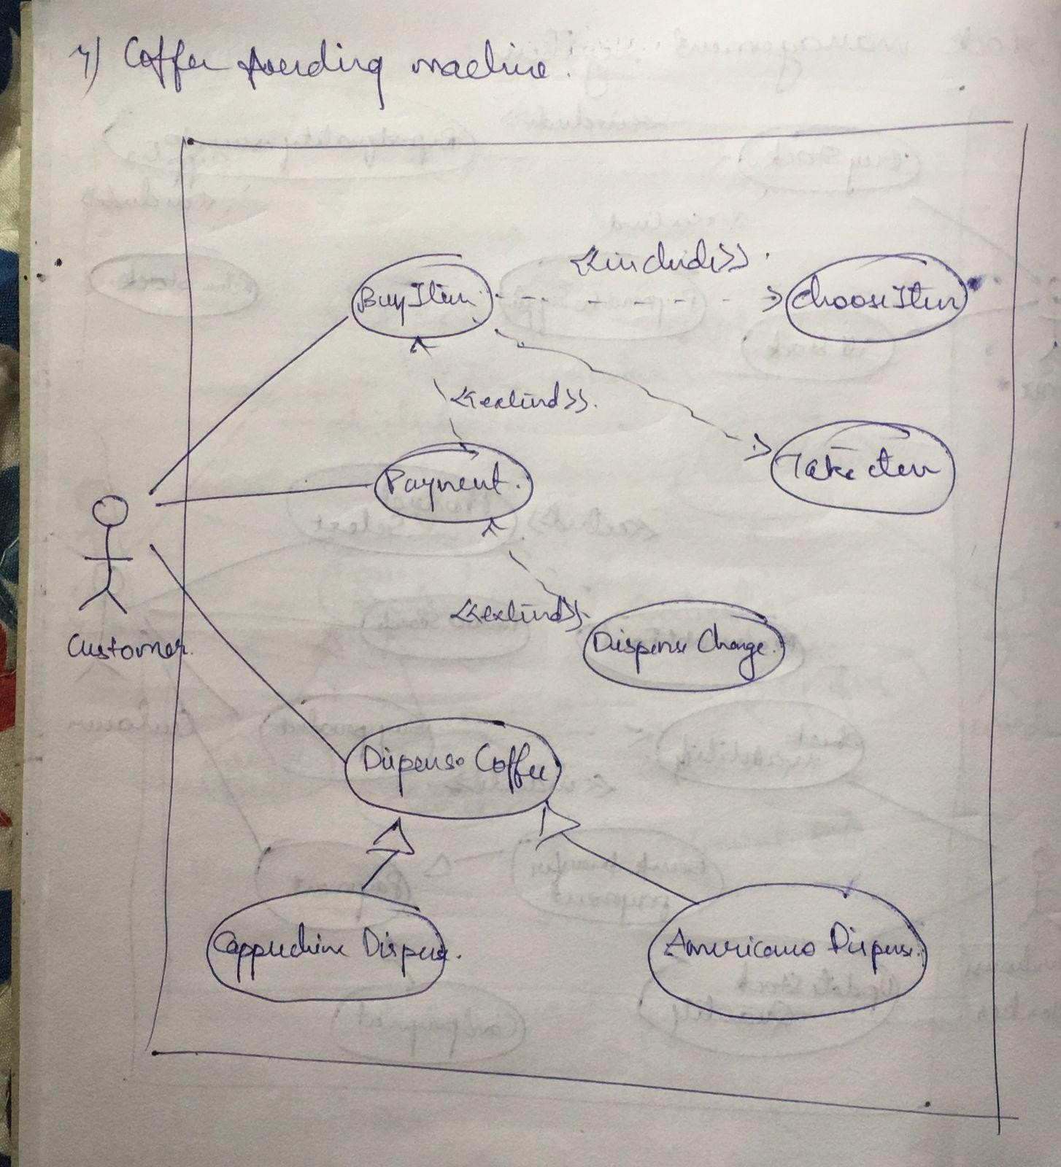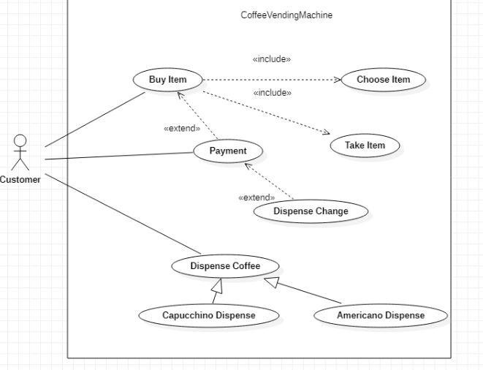

1. **Draw the advanced sequence diagram**

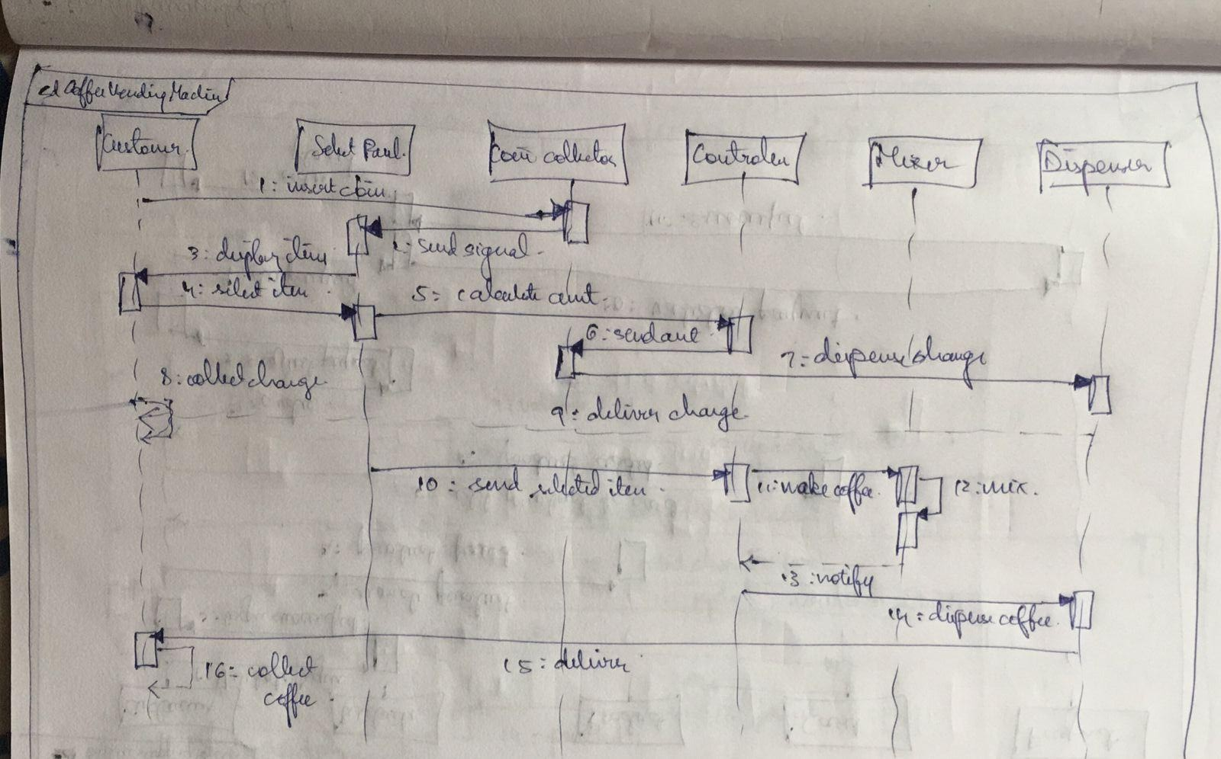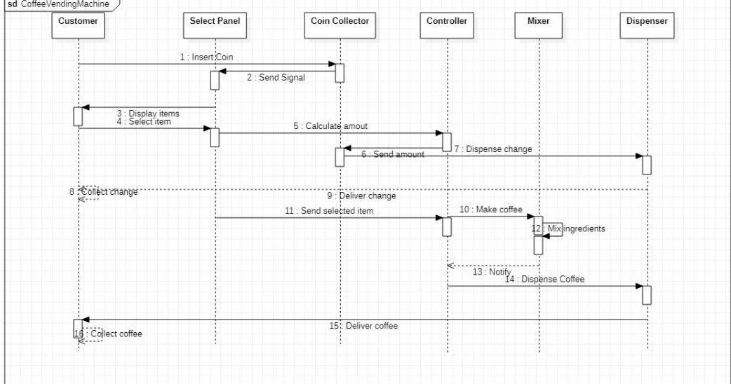

1. **Draw the advanced activity diagram**

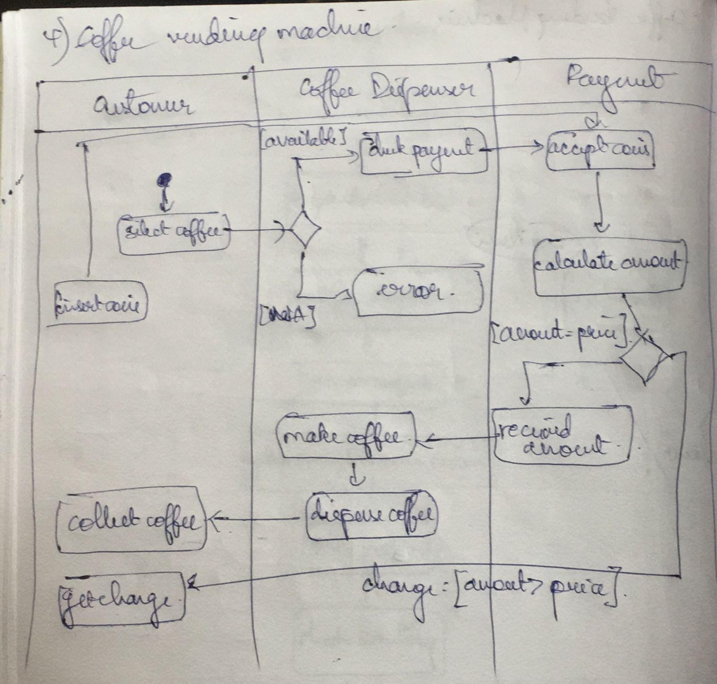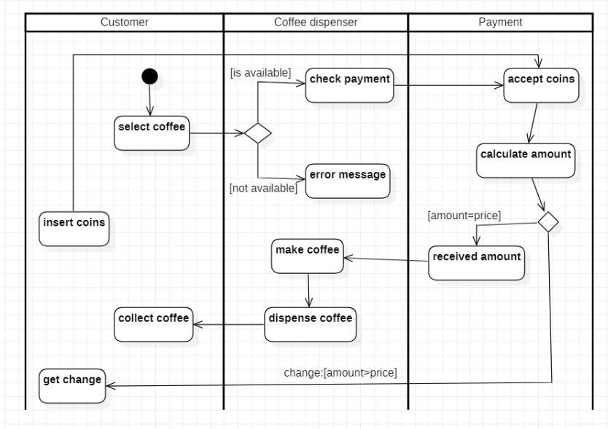

Exercise 5: Online Shopping System

1. **Write SRS**

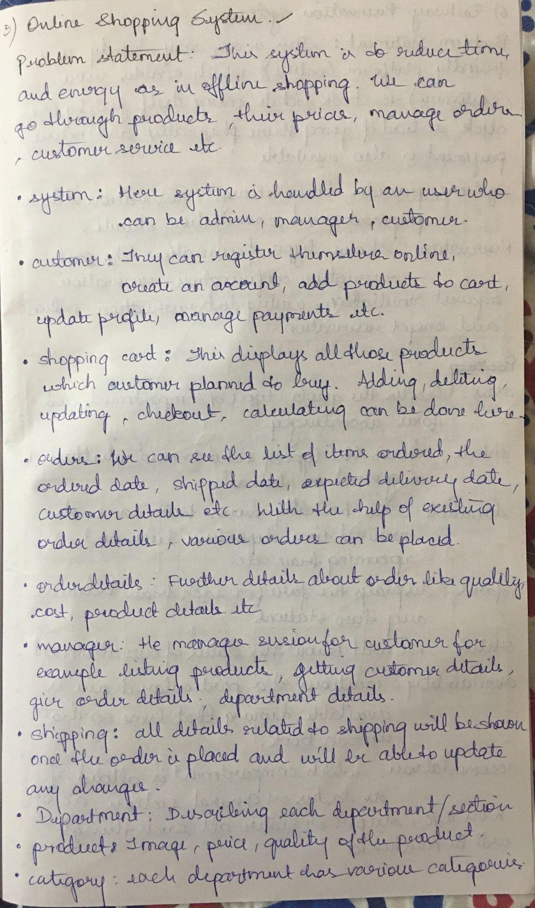

1. **Draw the advanced class diagram**

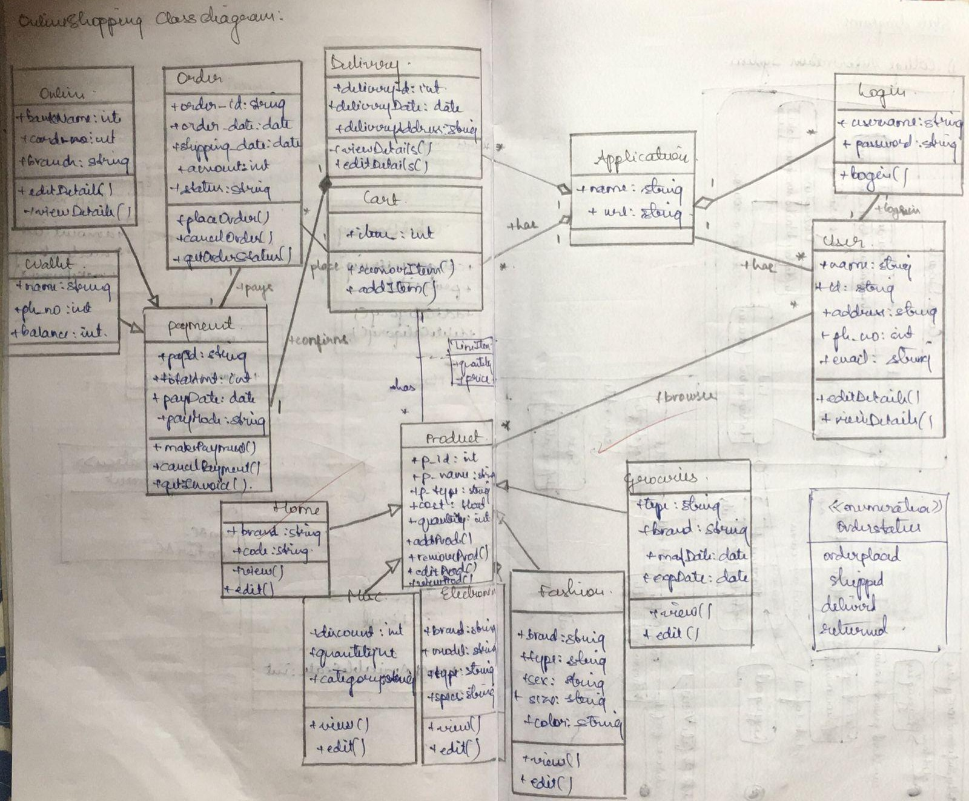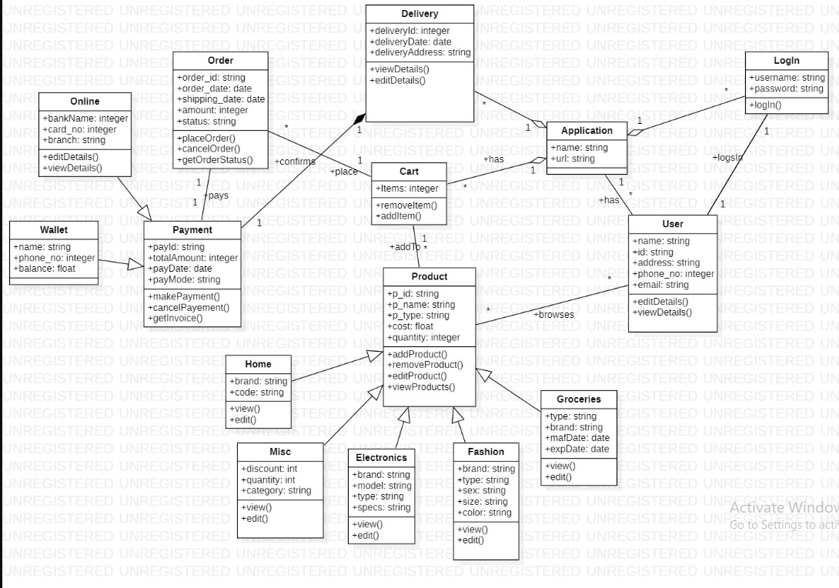

1. **Draw the advanced state diagram**

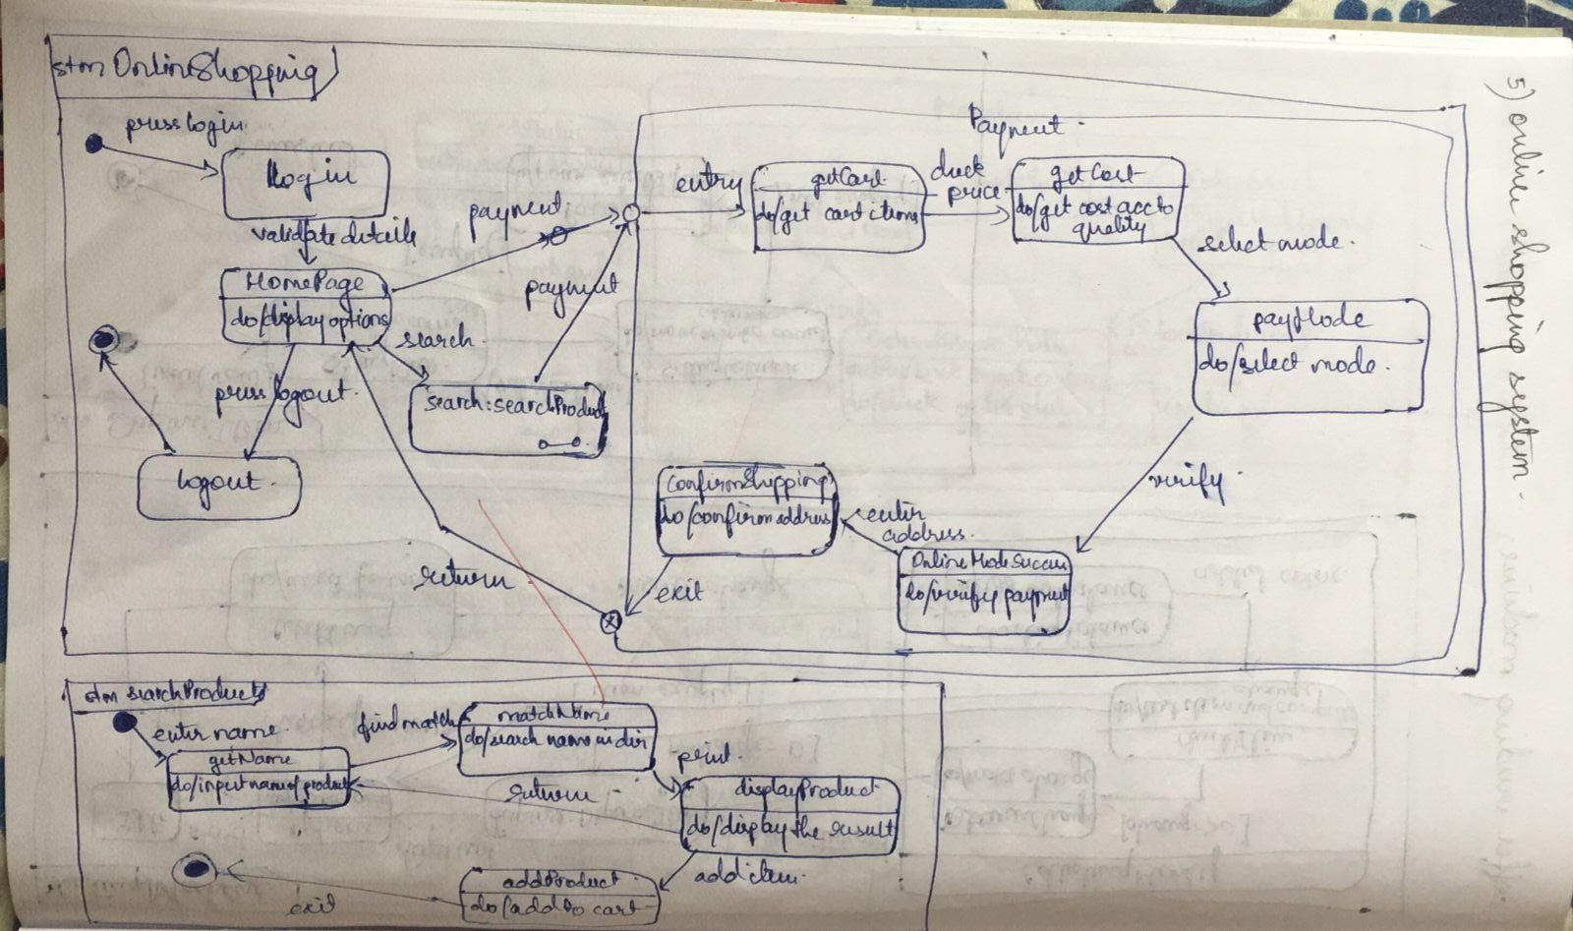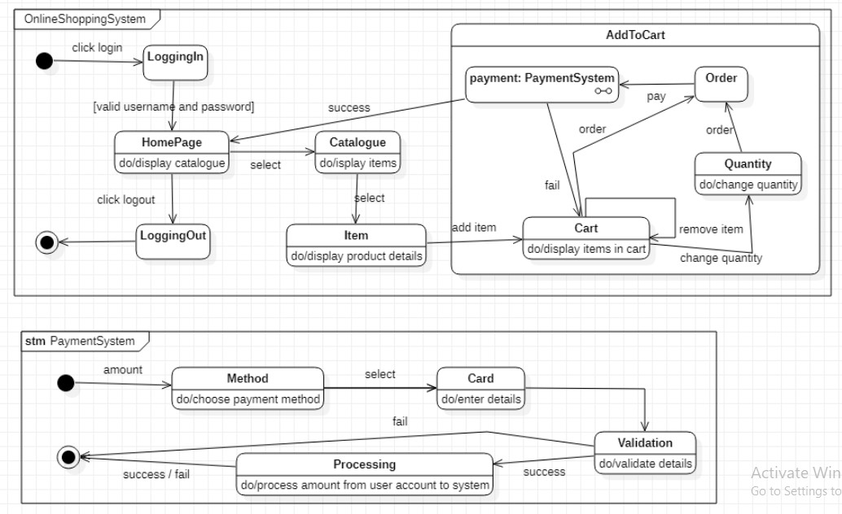

1. **Draw the advanced use case diagram**

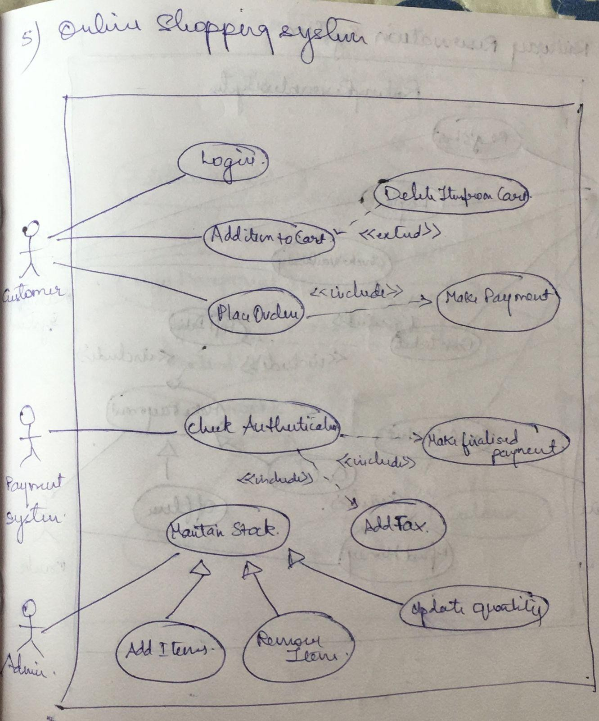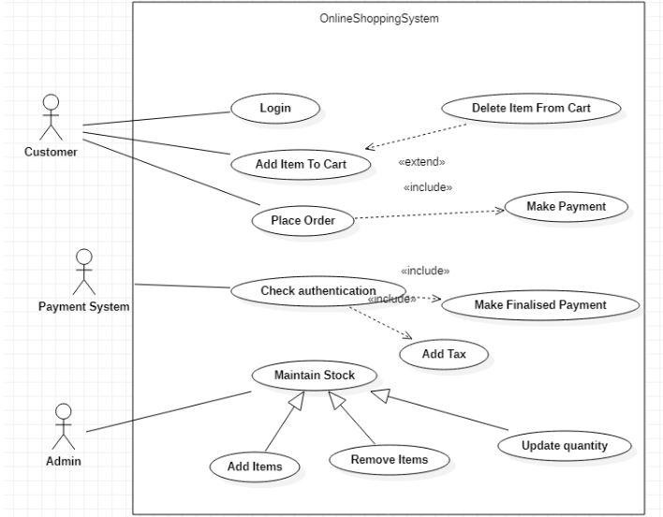

1. **Draw the advanced sequence diagram**

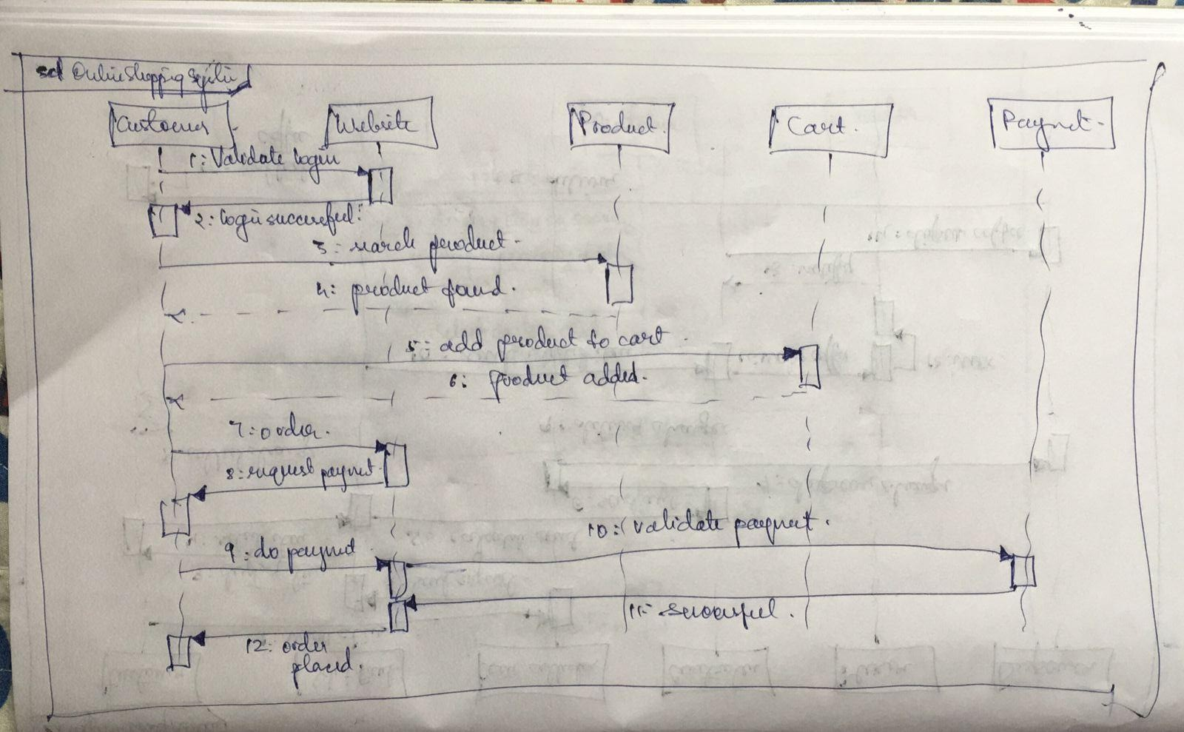

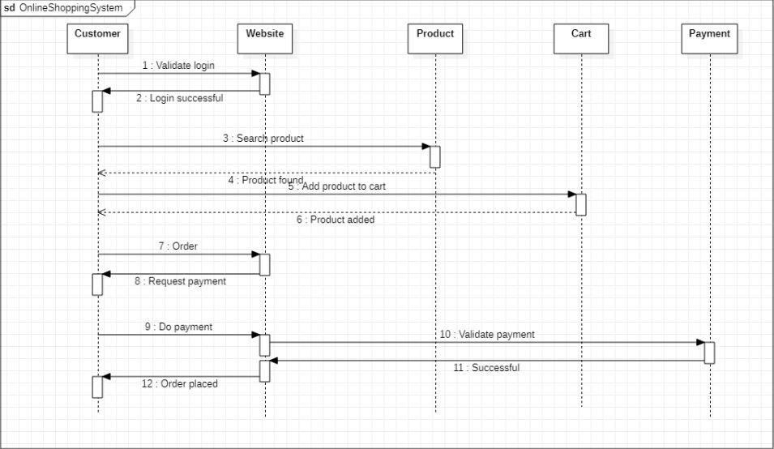

1. **Draw the advanced activity diagram**

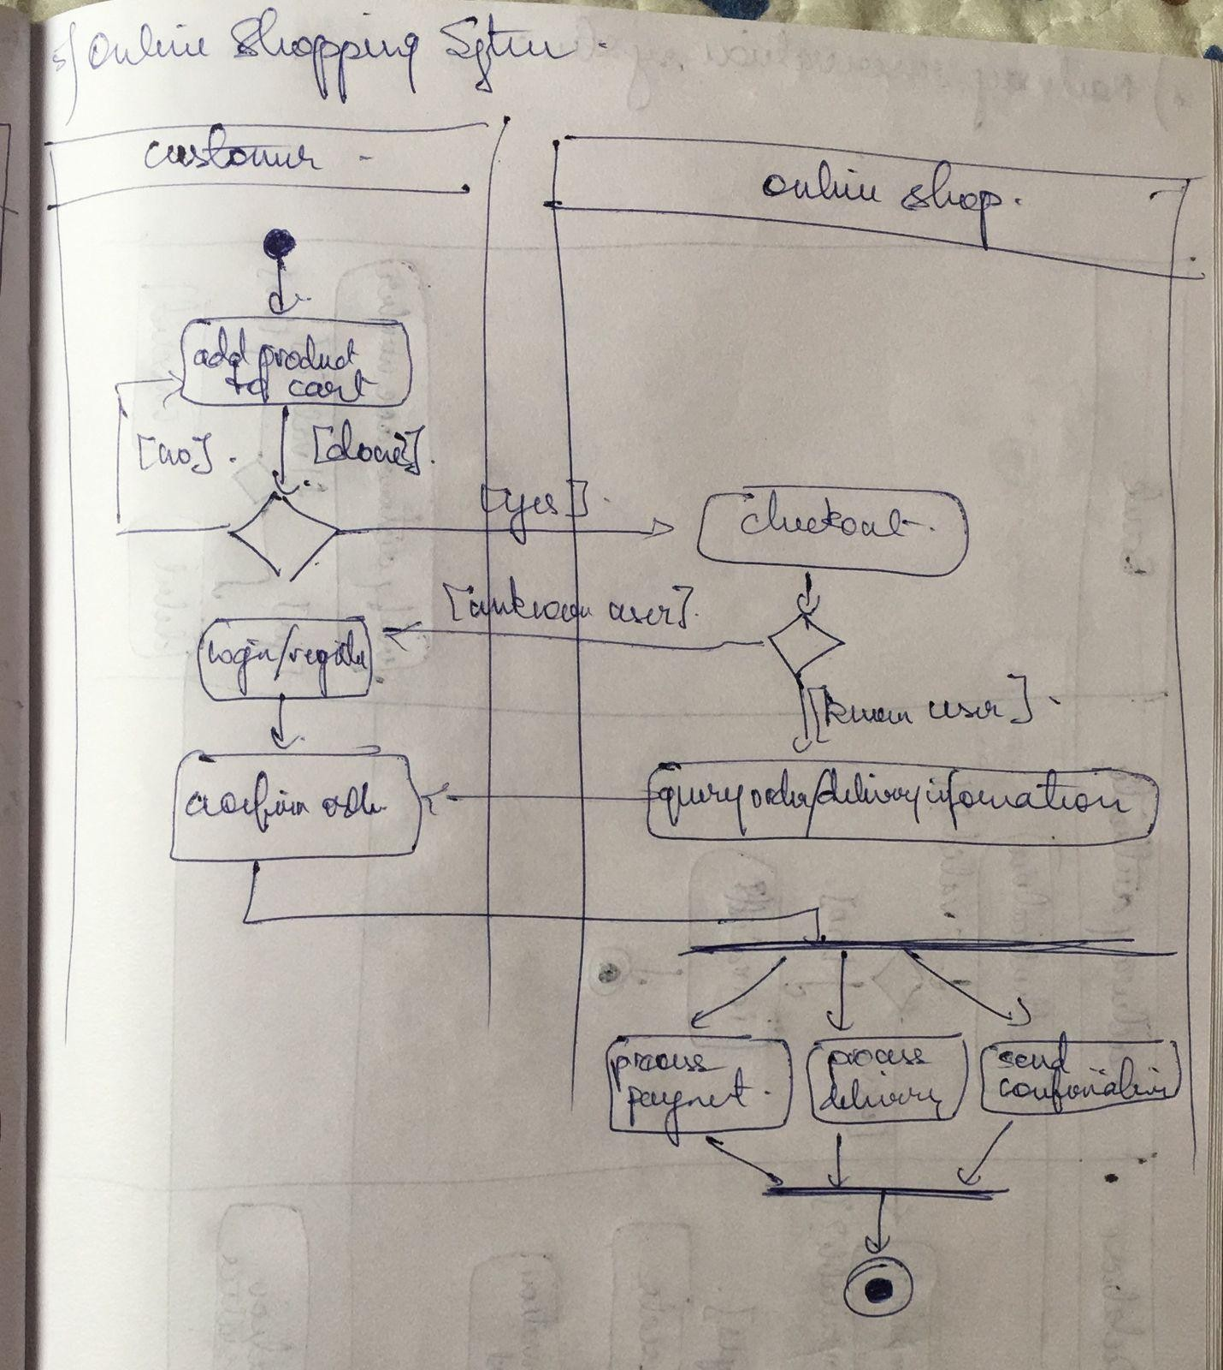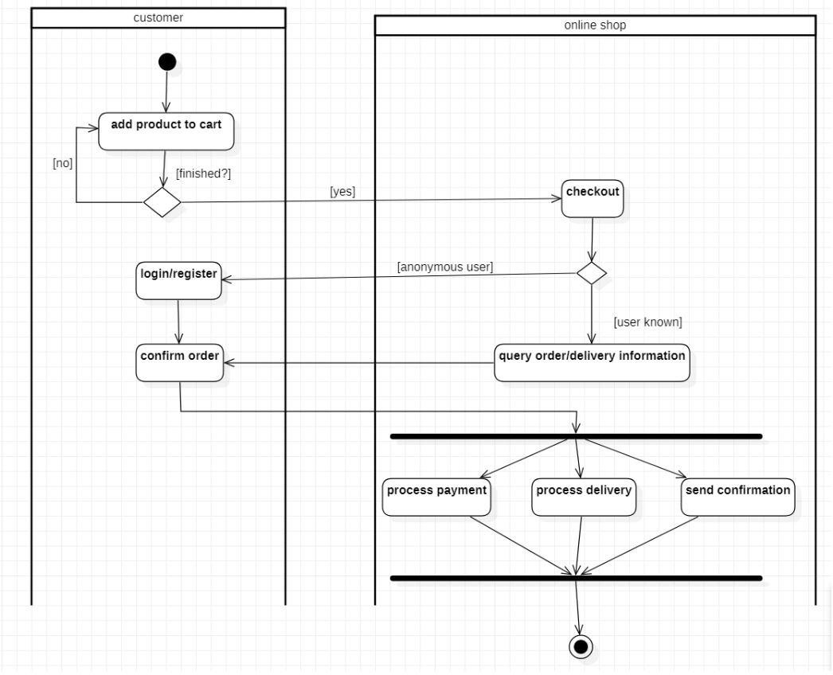

Exercise 6: Railway Reservation System

1. **Write SRS**

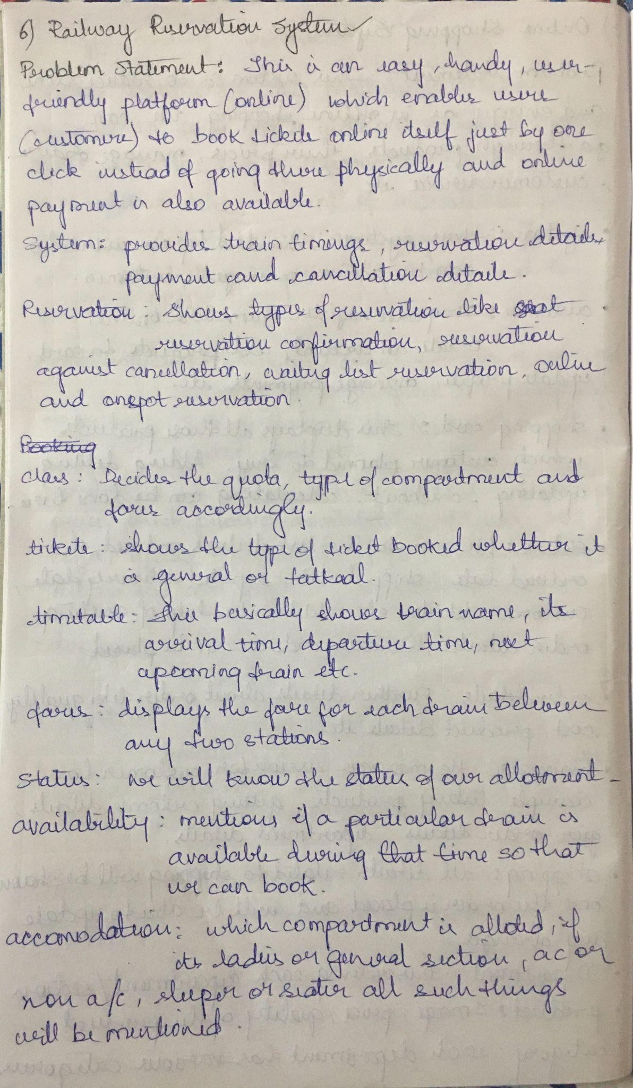

1. **Draw the advanced class diagram**

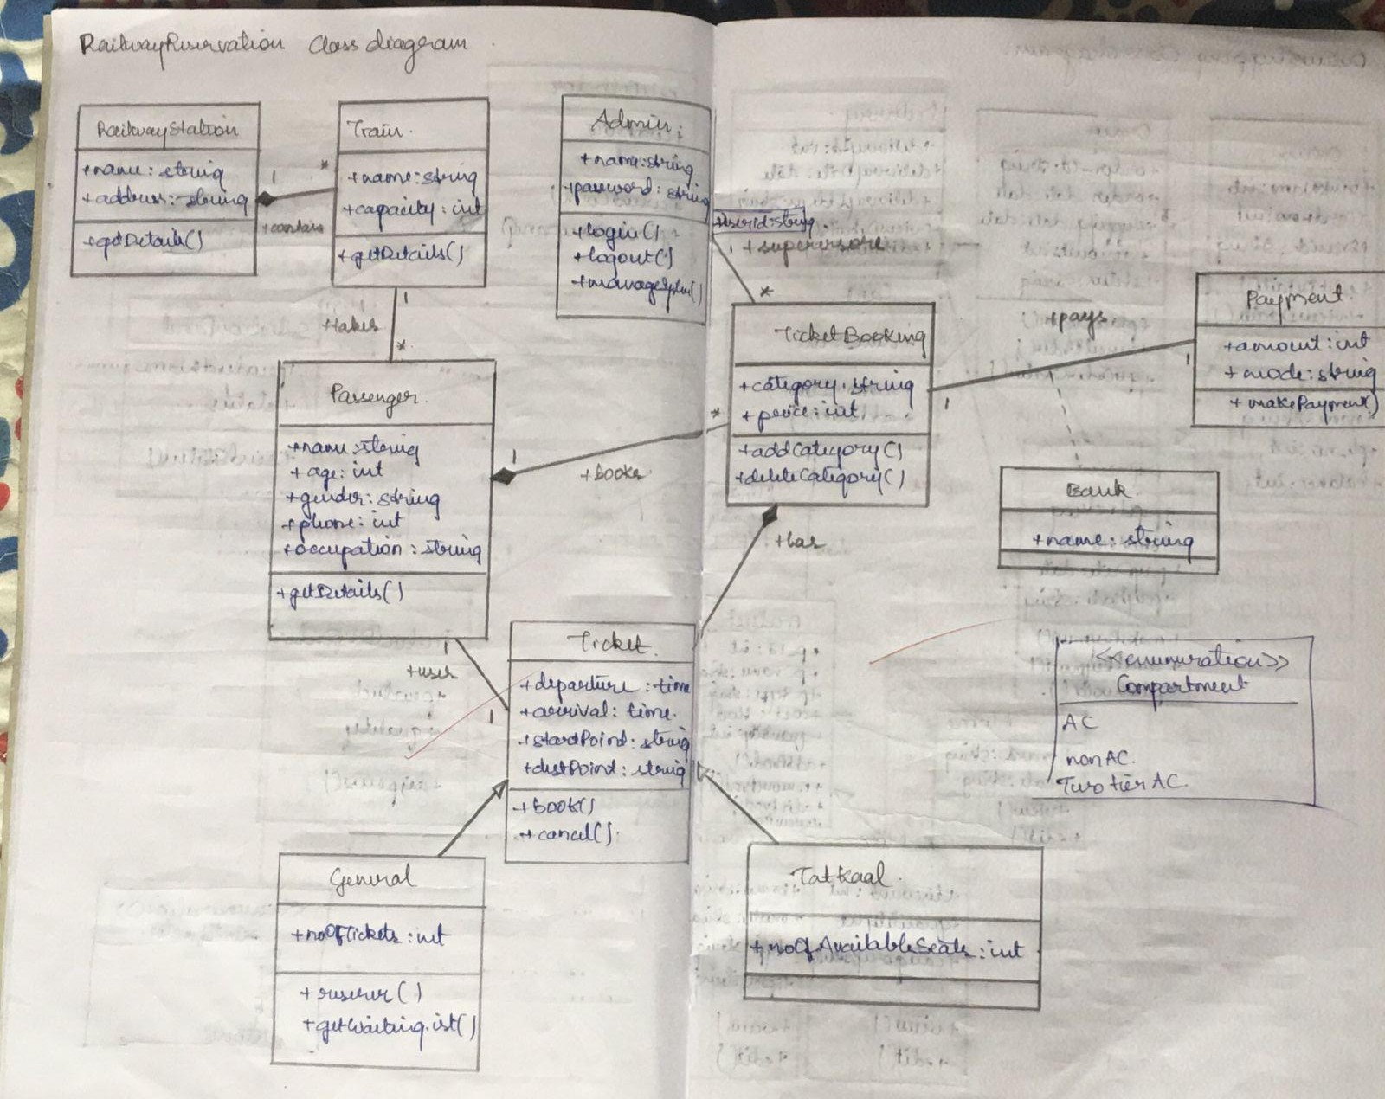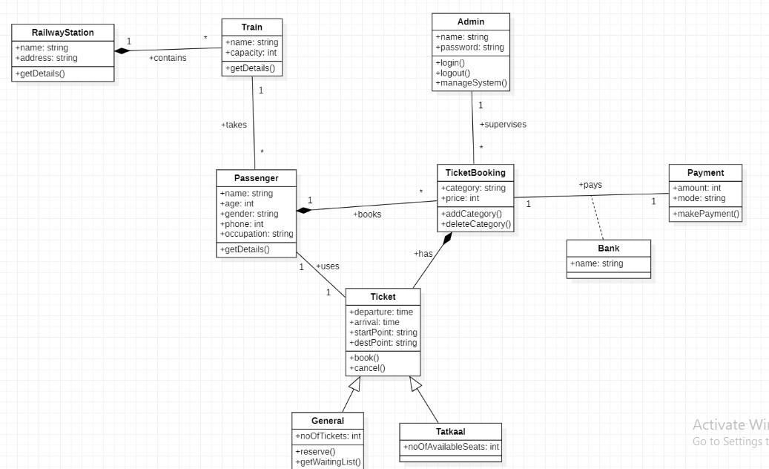

1. **Draw the advanced state diagram**

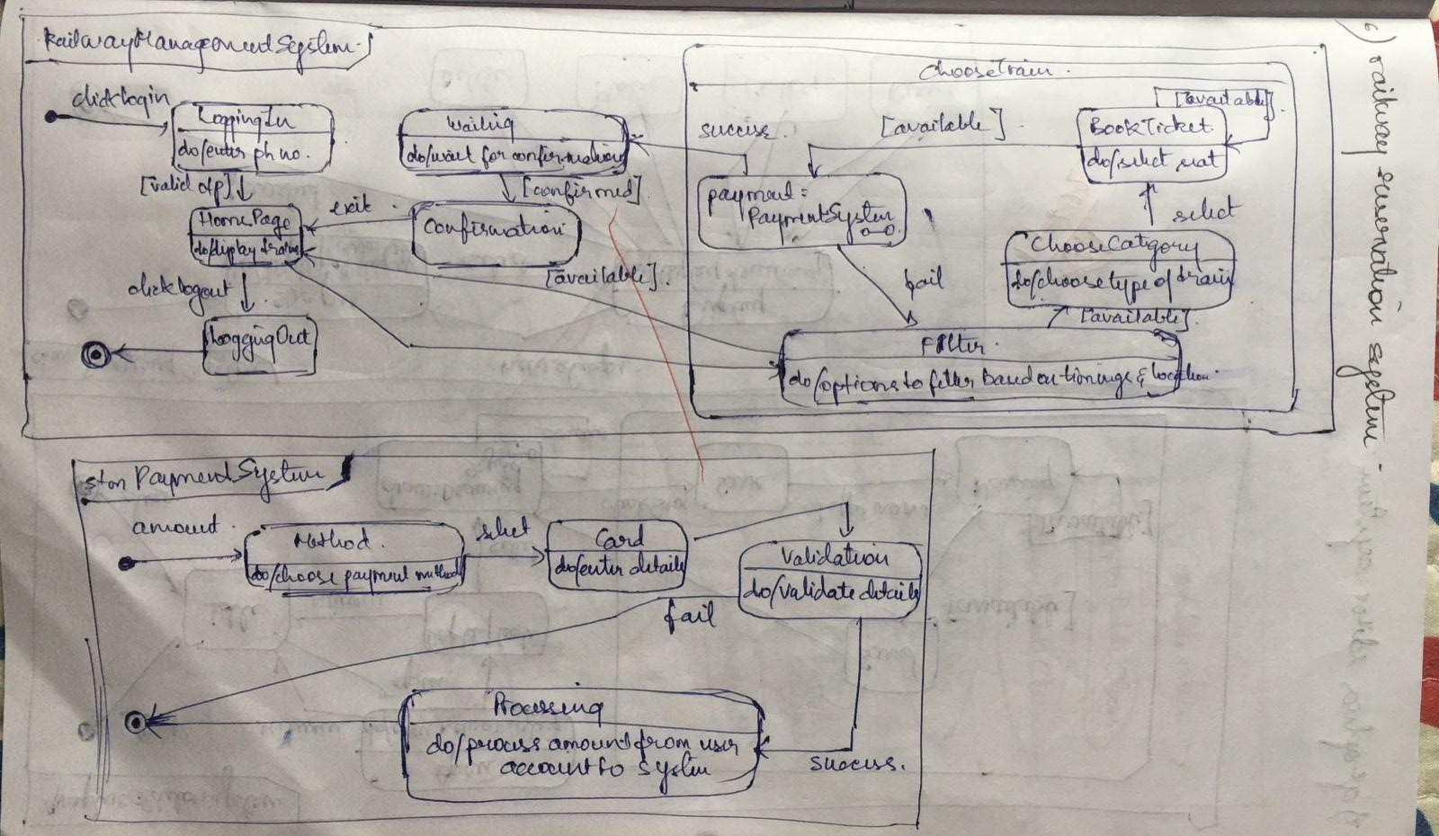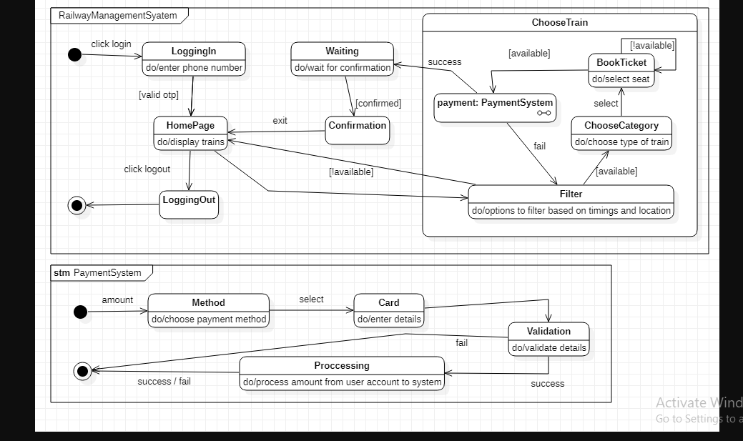

1. **Draw the advanced use case diagram**

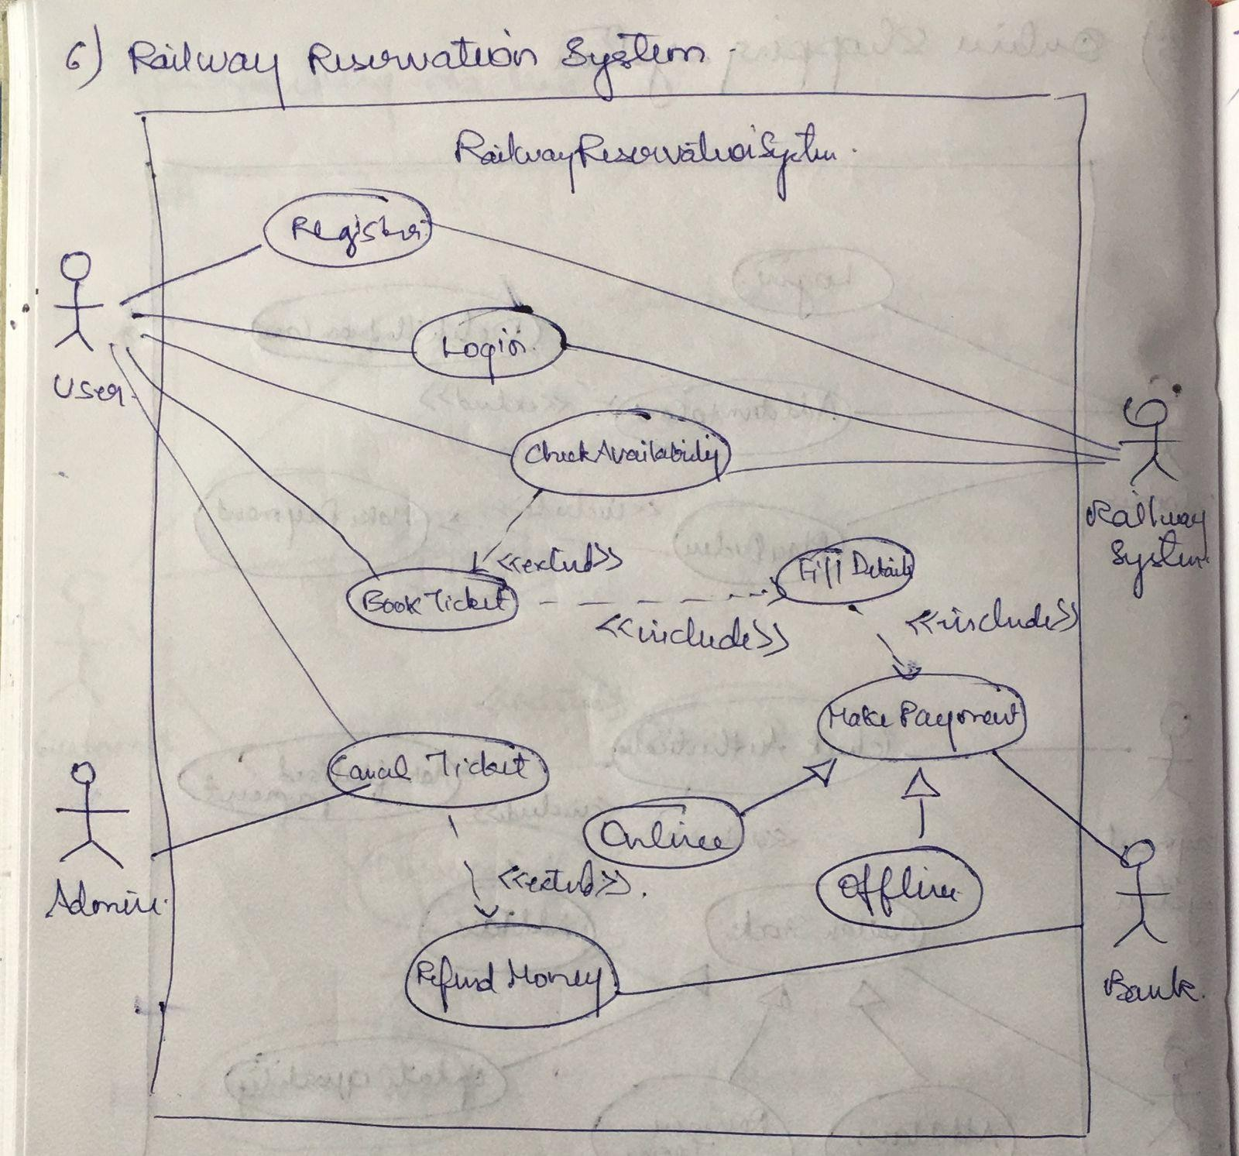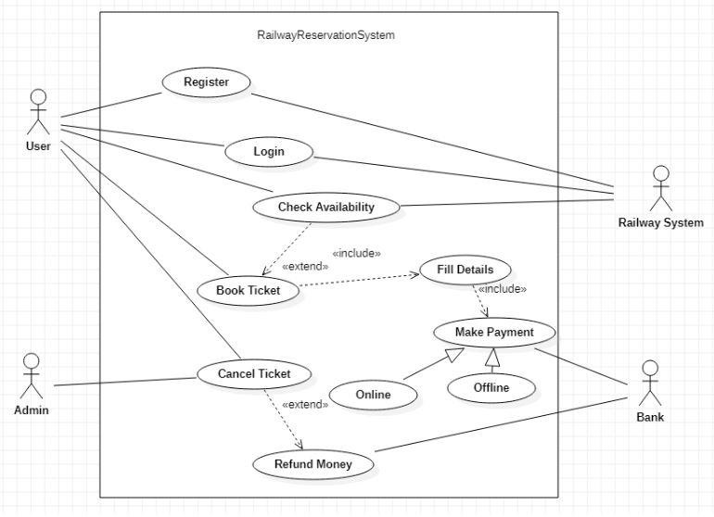

1. **Draw the advanced sequence diagram**

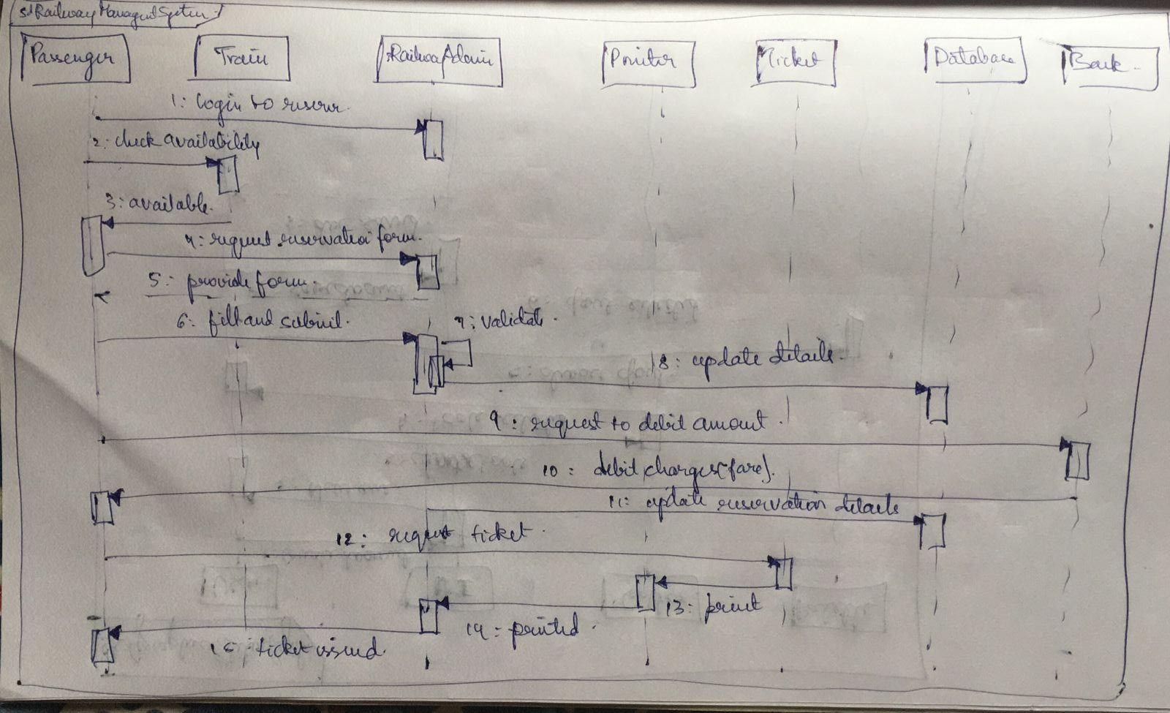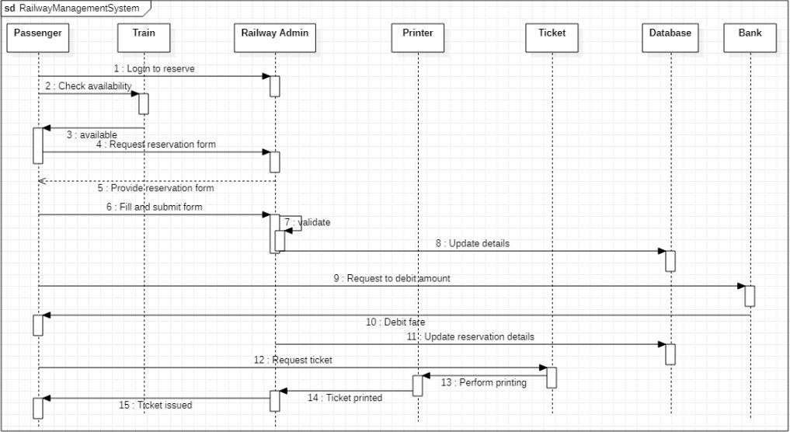

1. **Draw the advanced activity diagram**

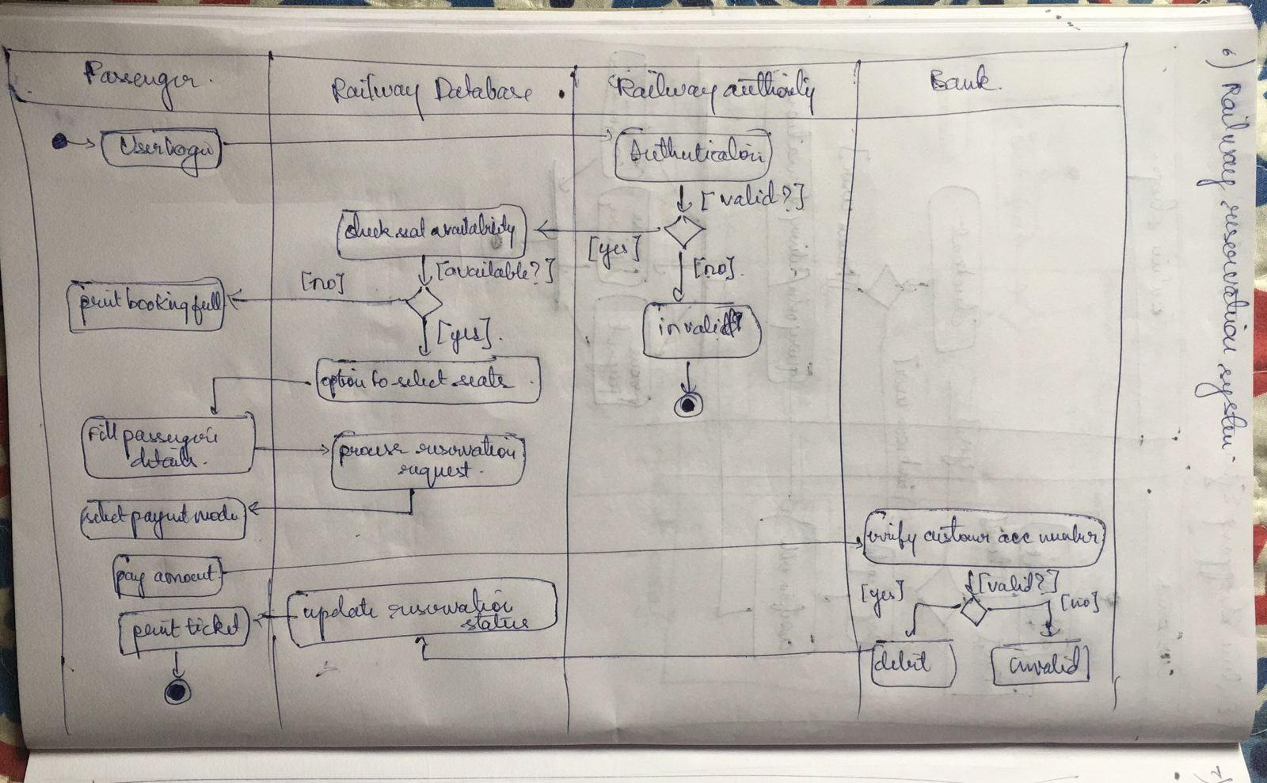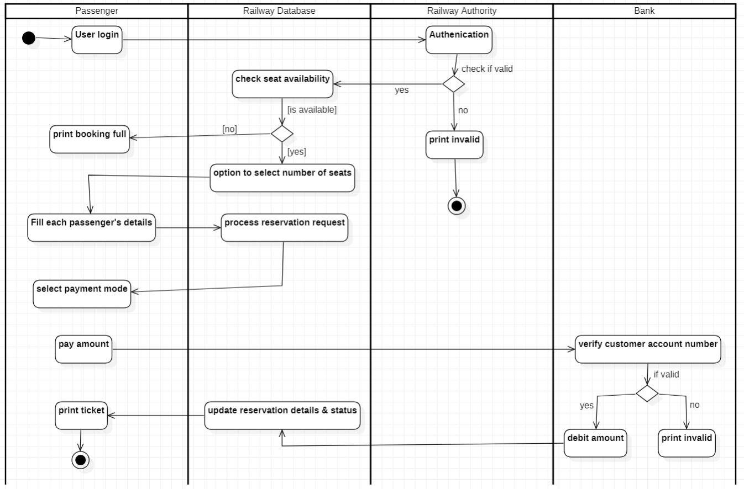

Exercise 7: Graphics Editor System

1. **Write SRS**

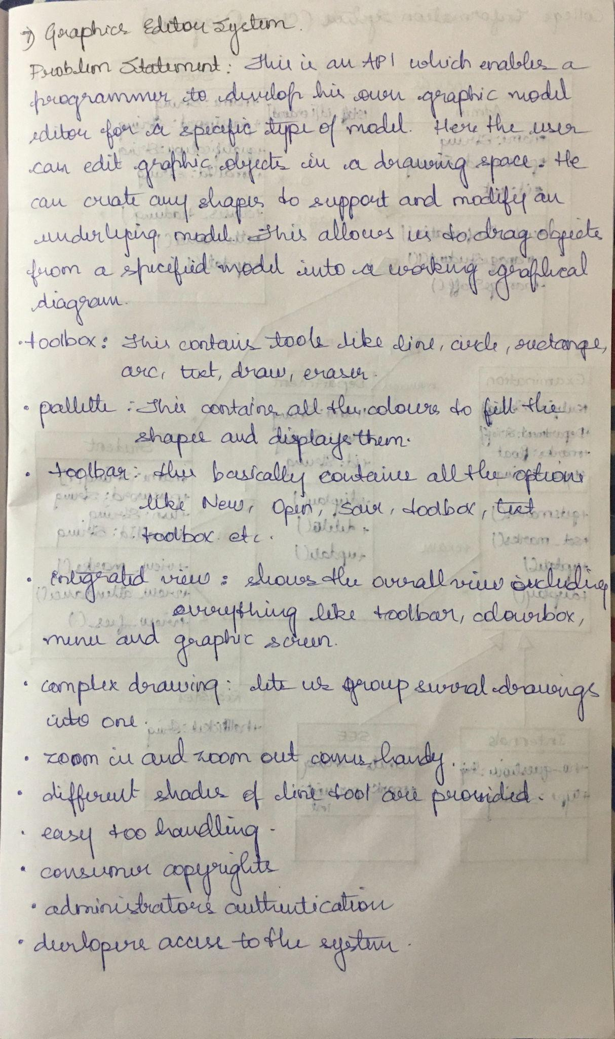

1. **Draw the advanced class diagram**

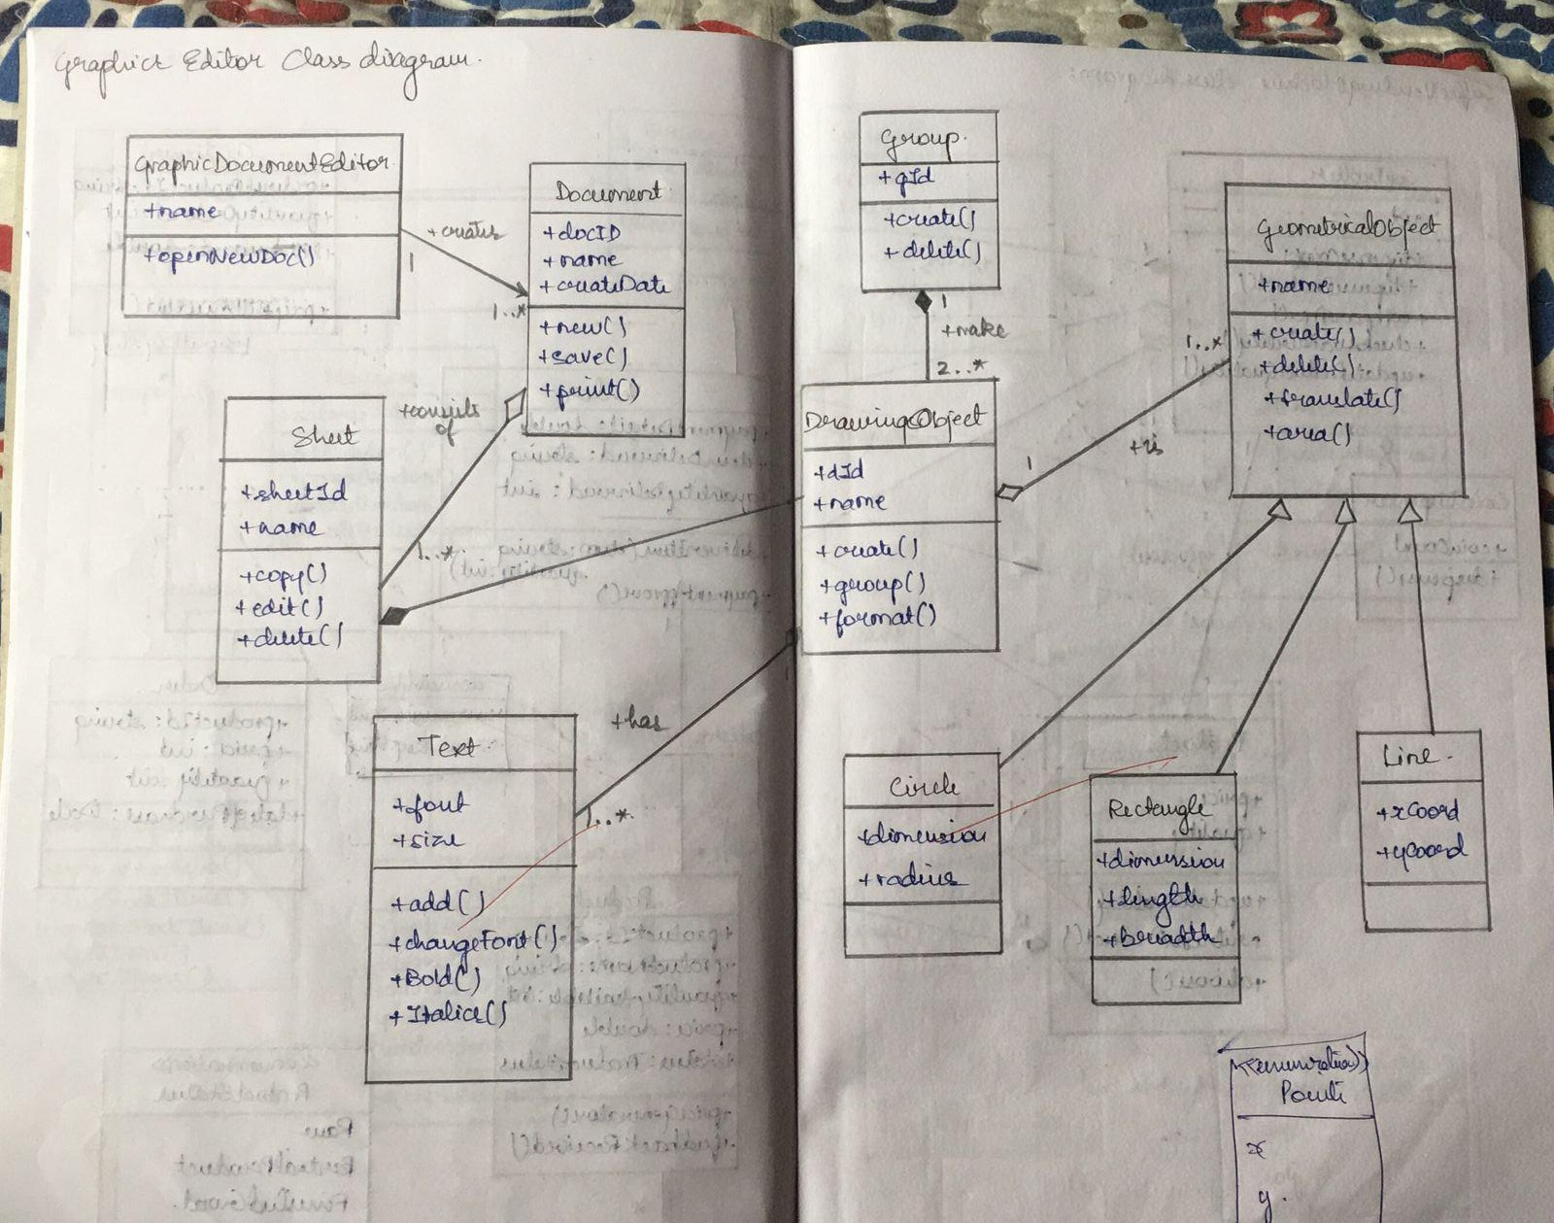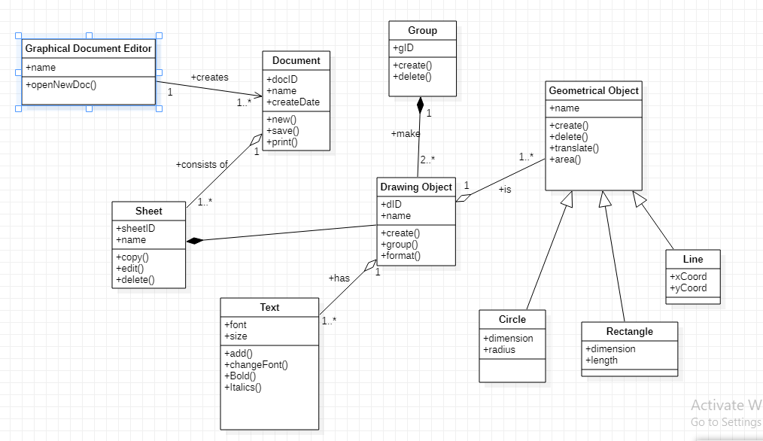

1. **Draw the advanced state diagram**

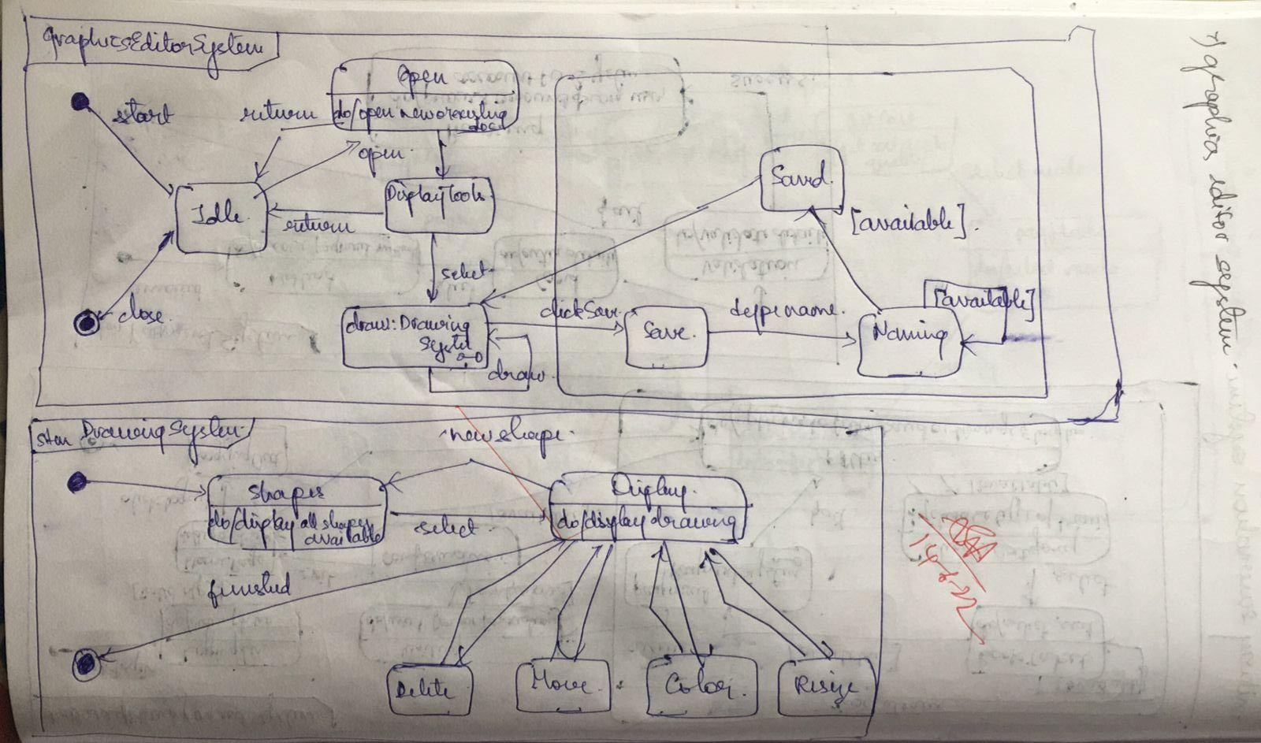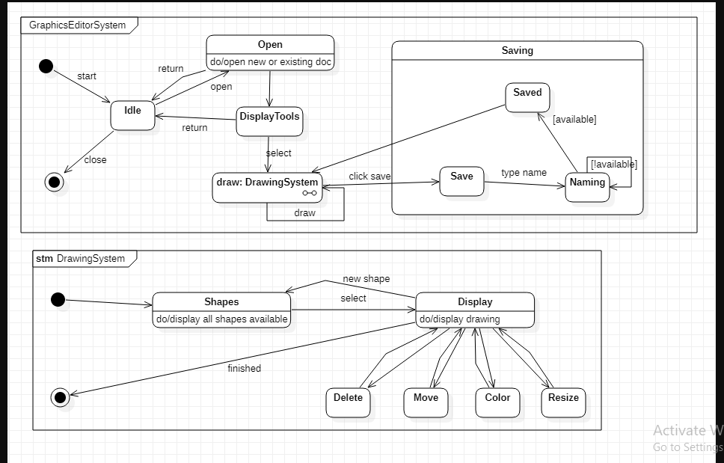

1. **Draw the advanced use case diagram**

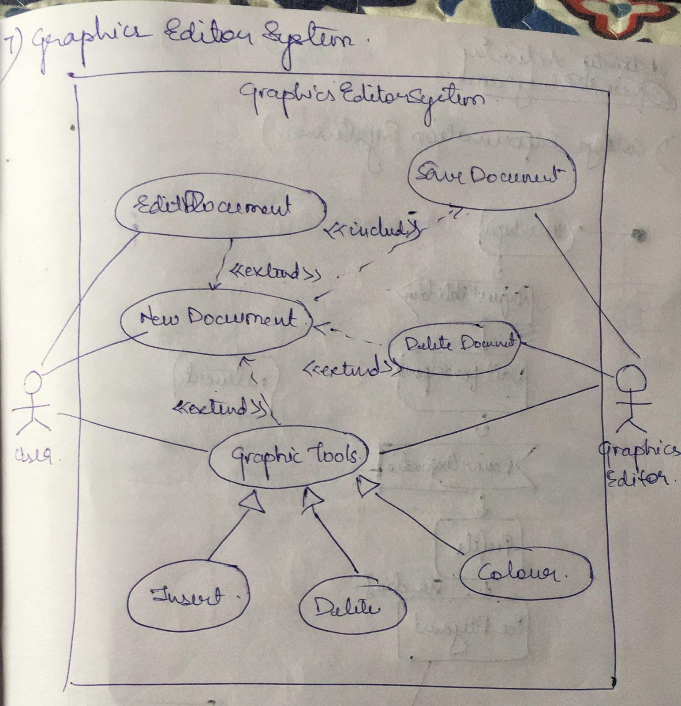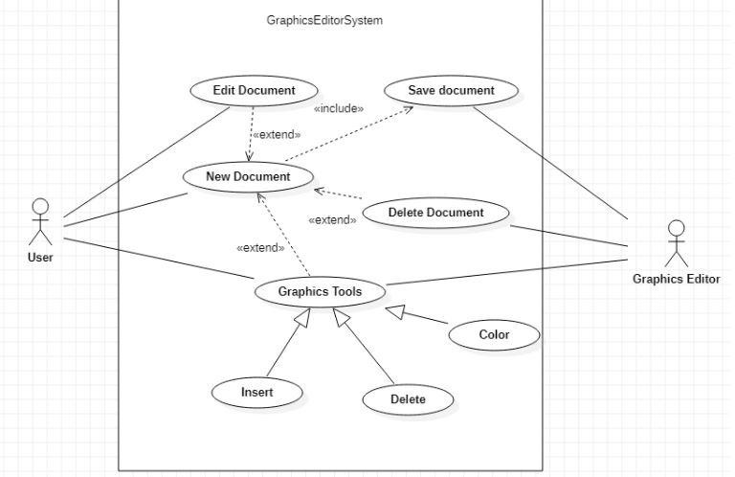

1. **Draw the advanced sequence diagram**

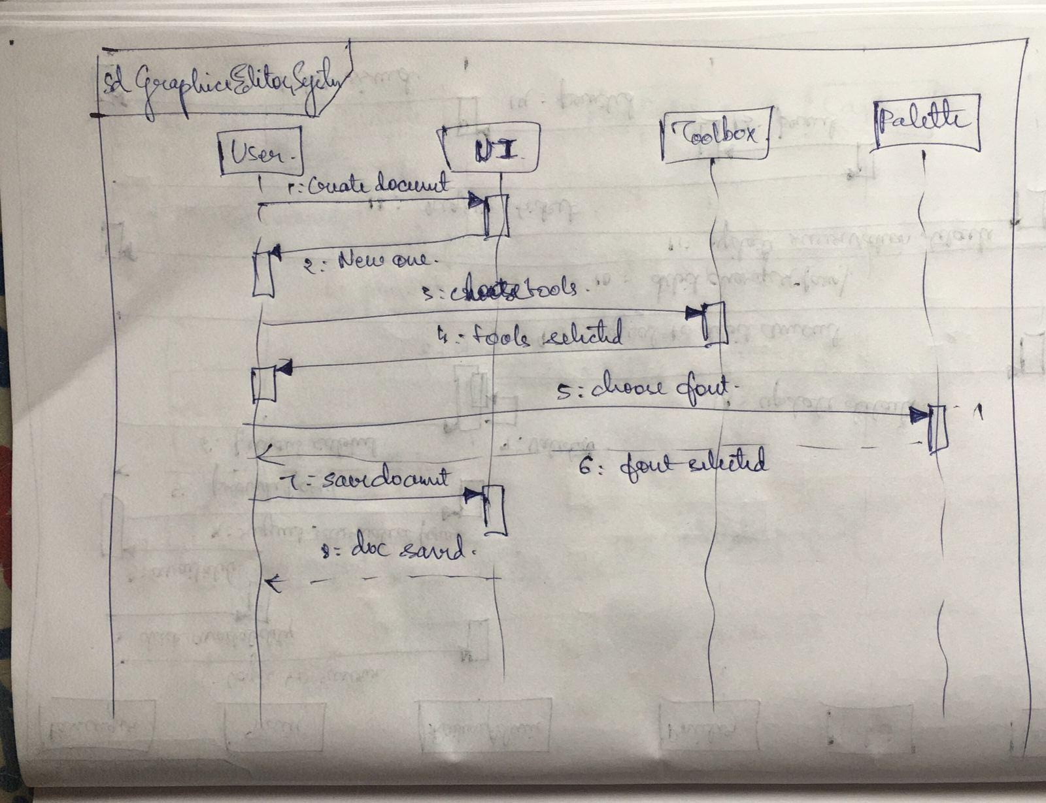

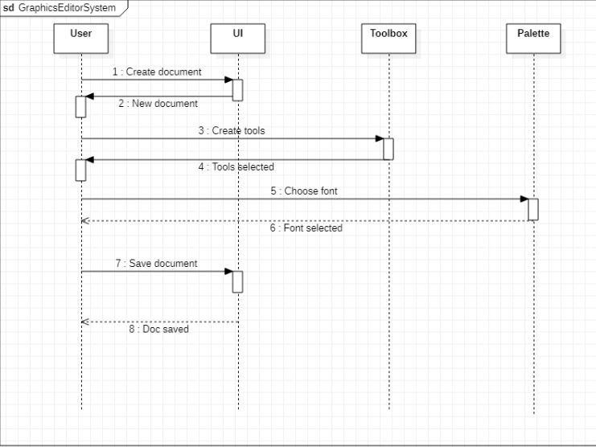

1. **Draw the advanced activity diagram**

